Local Government’s Guide to OTIMS

Introduction
The Online Transfer Information Management System (OTIMS) is being developed as a tool to assist in the development and transparent management of transfer allocations. It is an online database that is available on the Uganda Budget Website, which will act as a central repository for important information about local government grant allocations and performance.
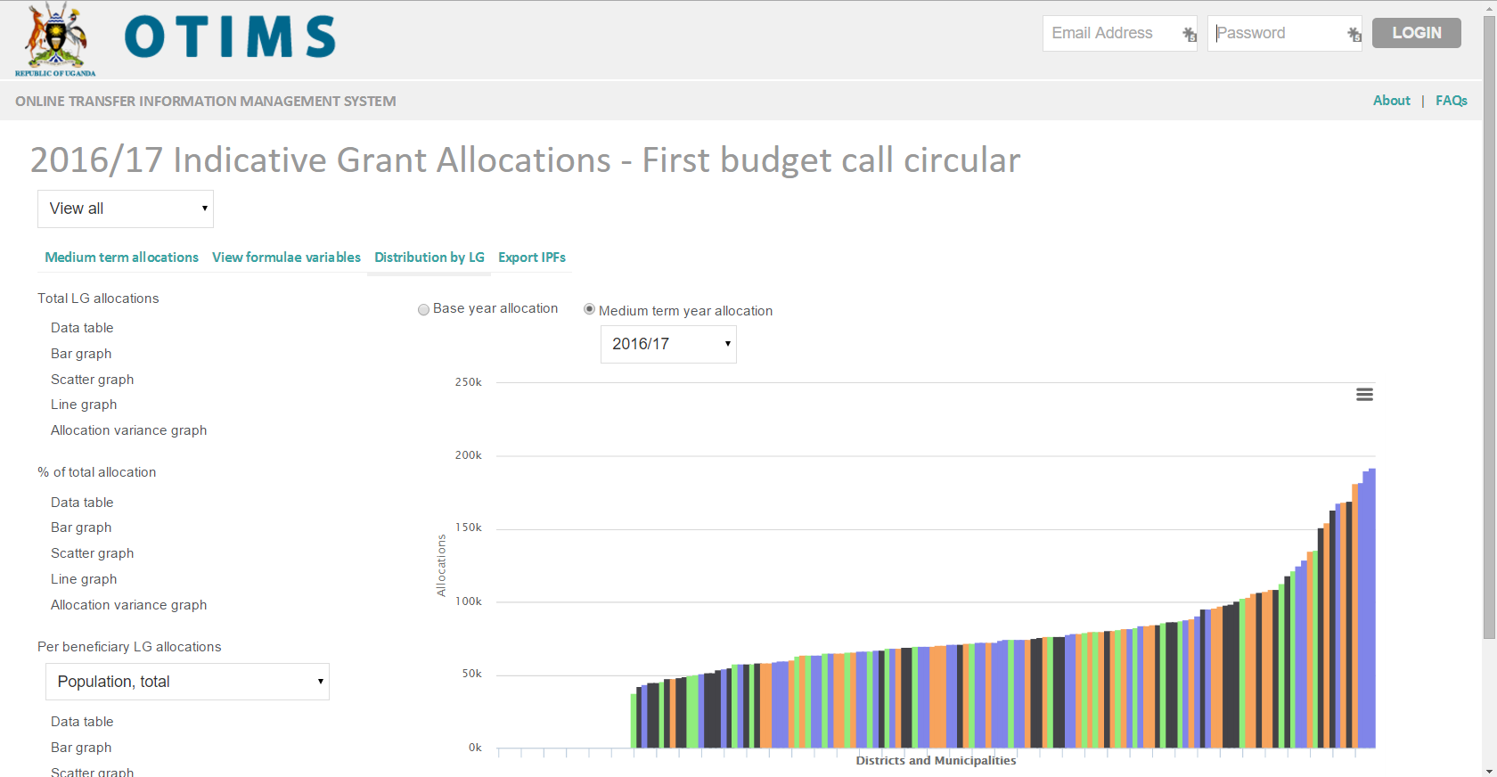
You can view allocation formulae and the data used to make budget allocations to local governments. You can also download IPFs and view medium-term budget allocations. Information is available on the variables and weights used in allocation formulae, and also access to IPFs and medium-term allocations. OTIMS allows you to understand grant allocation formulae and the allocations themselves. It also shows how your local government will be affected by the changes to grant allocation formulae.

Getting started
OTIMS can be accessed at the following URL with the long in details listed below:
- URL: http://budget.go.ug/fiscal_transfers/
This takes you to a page where you can explore the most recent transfer allocations, overall and by individual grant and formula.

Finding a formula
The drop-down menu at the top of the screen (set at “view all” by default), which shows information on all grants and formulae. The drop down can be used to narrow down which sector, vote functions and grant you are interested in. This is illustrated in the screenshot below for the health sector (selecting the primary health care wage grant).
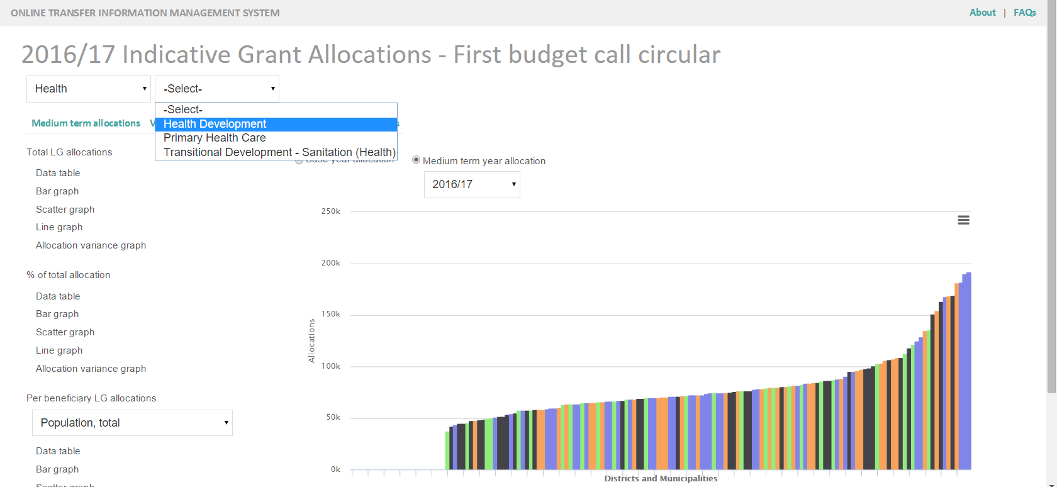
Once you have selected the grant (or group of grants) that you are interested in, you can click on one of the following headings to begin your analysis (the ones in bold will be most useful):
- ‘Select formulae’ to be analysed
- ‘Formula Variables’ and their weightings
- ‘Medium Term Allocation’ and the rate at which formulae are phased in
- ‘Export IPFs’ for all grants into Excel
- ‘Distribution by LG’ of the formula and roll out plans

View formula variables
Click on “view formulae variables” and you will see a window with all the variables used listed down the left and the name of the grant along the top. The weighting given to the variable will be displayed below the grant name. For example, rural population has a weighting of 30/100 in the formula used to allocate the District DDEG – Other grant. Details of these variables are available in the ‘datasets’.
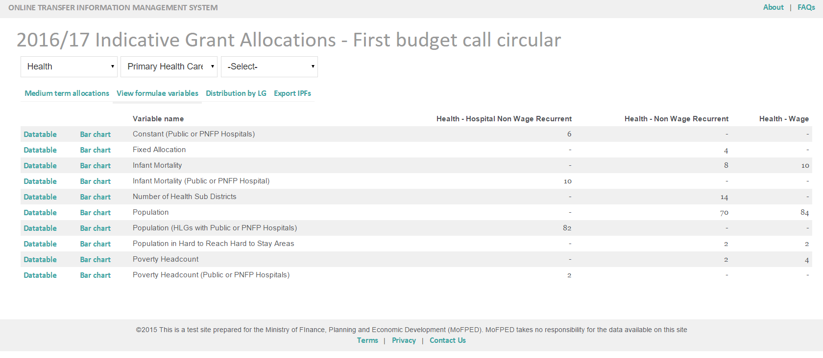
You can view the values of and bar charts of the individual variables underlying formulae.
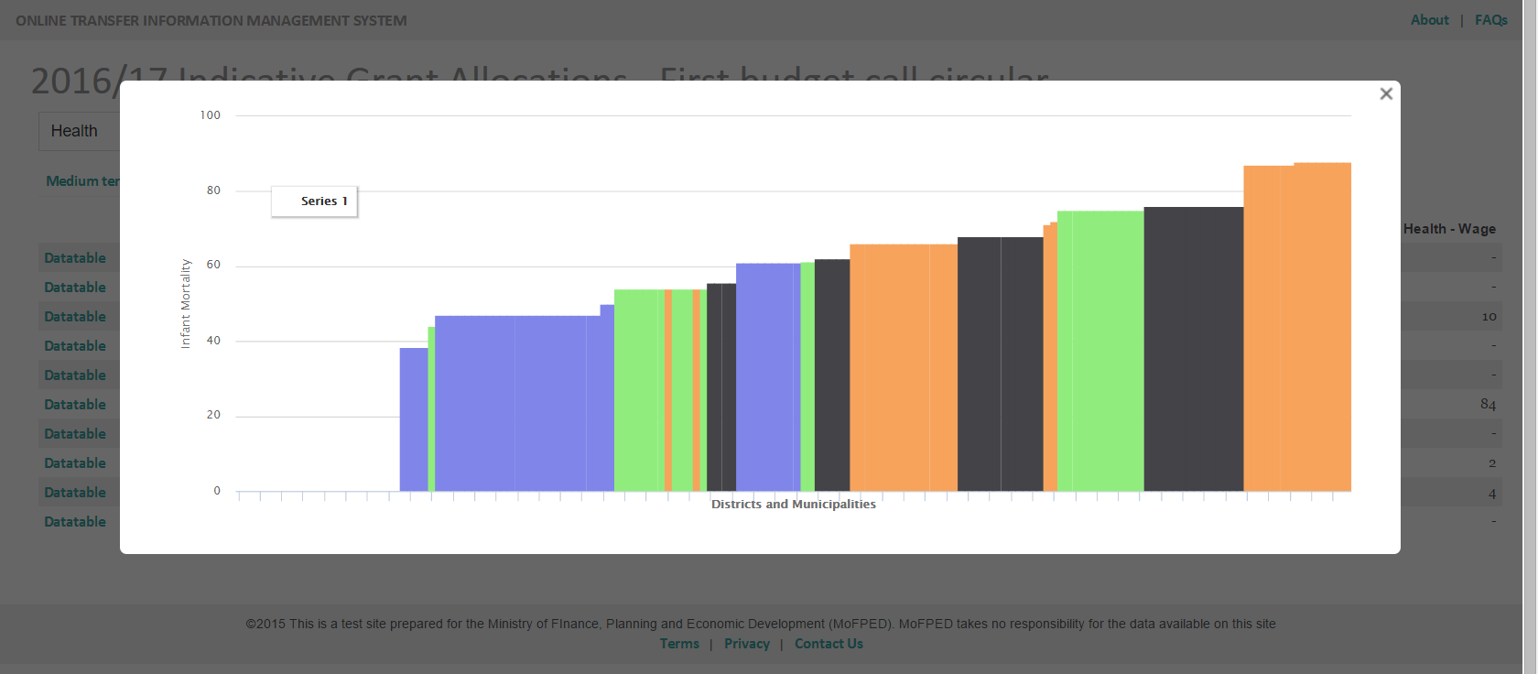

View medium-term allocations
Click on “medium term allocations” to see (a) the estimated value over the medium term, and (b) the percentage of the formula that has been phased in for a given year.
You can view information for all grants, or choose to select a sector or specific grant as described earlier. You can also choose to see how much would be allocated to a specific local government. To do this, use the two dropdown menus – ‘Select region’ and ‘Select district’. Select the region of interest, and then the district from the drop down menus. Click ‘View’.
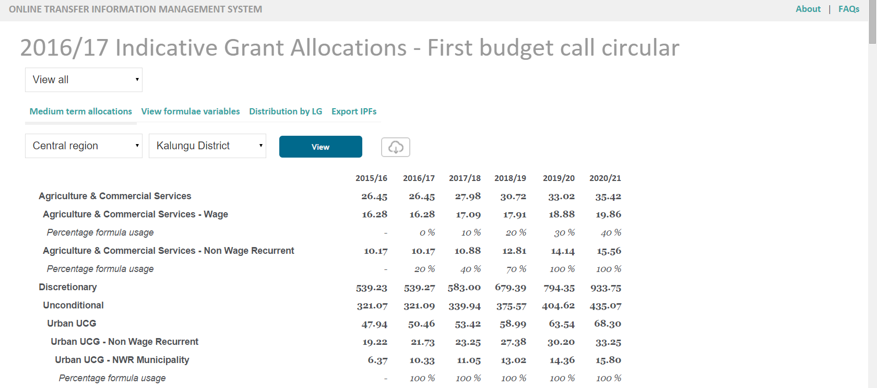

Visualise Distribution by Local Government
Click “Distribution by LG”. This will reveal a number of standard options to visualise allocations. These can make two broad comparisons:
- Base year allocation: this applies the new formulae to the current budget (2015/16 in this example). This is compared against the budget allocations, unchanged.
- Medium term year allocation: this will show the allocation information in a future year, consistent with the Budget Call Circular. This is compared to the current budget allocations.
Once you have chosen this (for example, to see the allocation for next fiscal year) there are five standard ways of viewing the data:
As a data table where the allocation based on the new formulae is compared to the base allocation, and the difference calculated
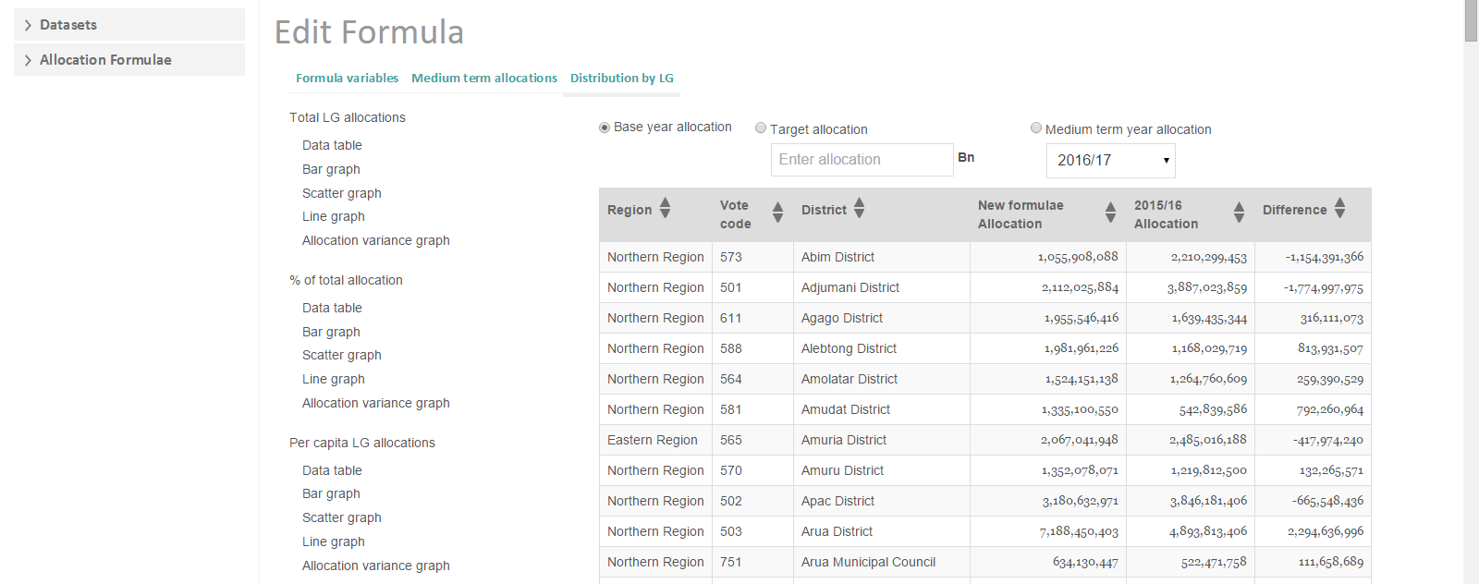
As a bar chart showing the distribution by local government of the new formula allocation
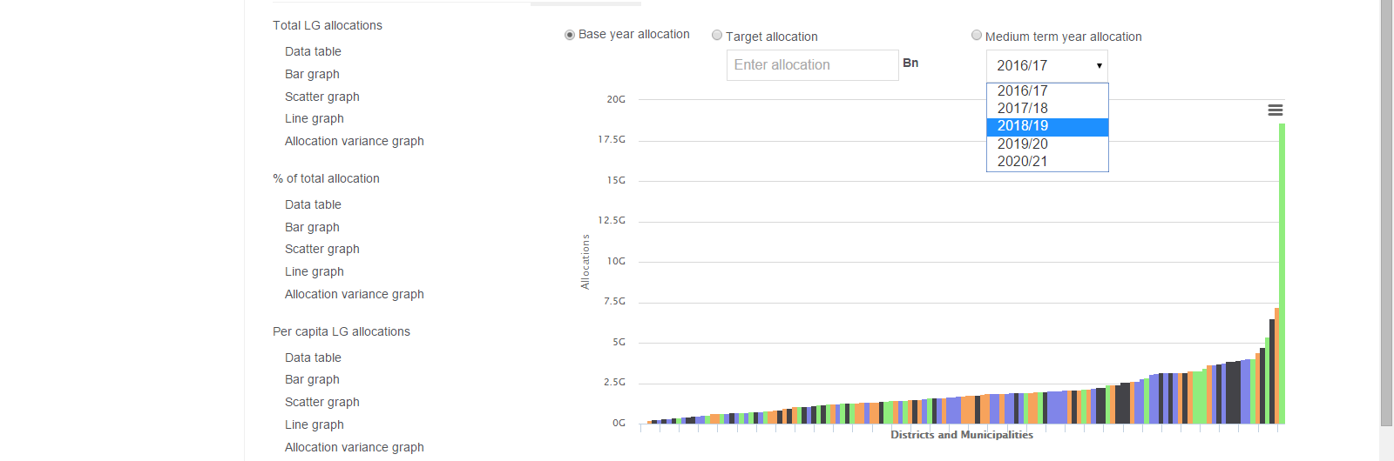
As a scatter chart showing the correlation between the new formula and the base allocation
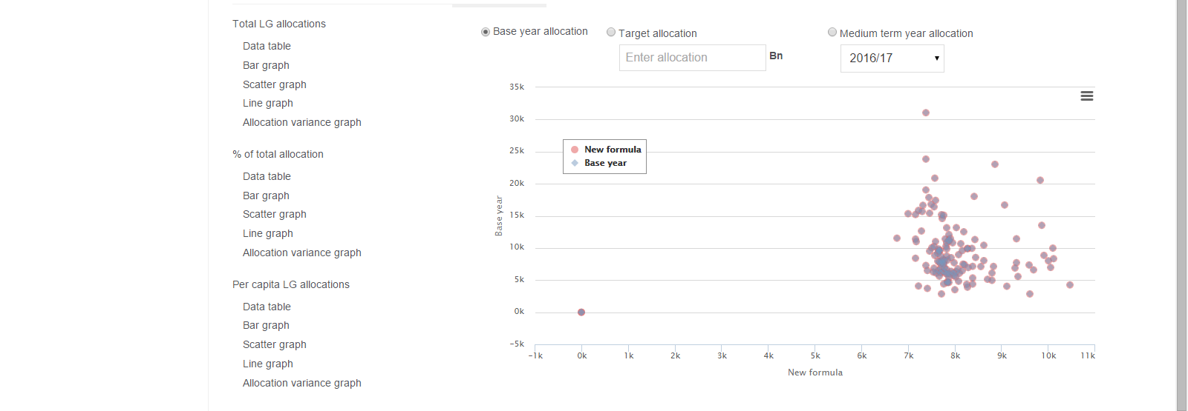
As a line chart comparing the distribution by local government of new allocation with the base-year allocation.
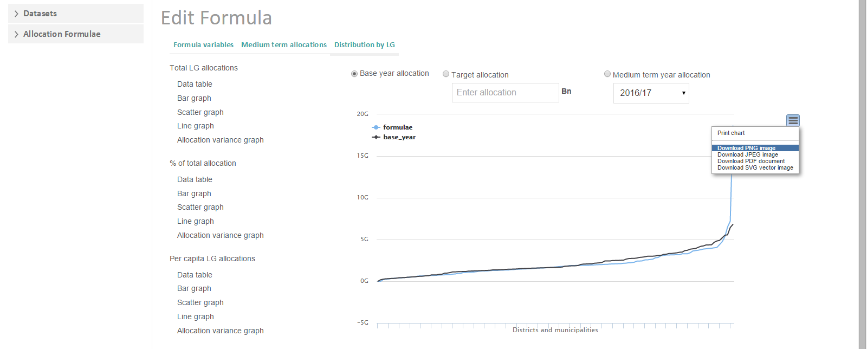
And finally as a bar chart showing the allocation variance between the base allocations and the new formula allocations. The local governments on the right hand side of the chart above the line are those which stand to benefit with increased resources from the new formula.
