THE CIVIL SOCIETY POSITION PAPER ON THE OPPORTUNITIES AND CHALLENGES TO SERVICE DELIVERY AND BUDGET IMPLEMENTATION

Presented at the Regional Budget Consultative Workshops for the financial year 2017/18

September, 2016
Contribution to this paper was coordinated by the following CSOs
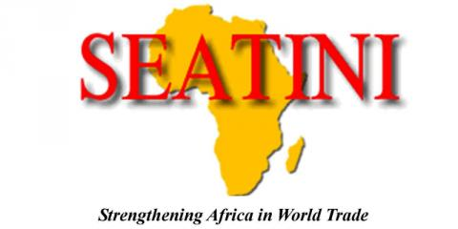
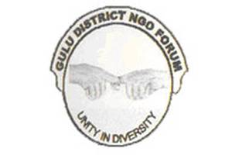
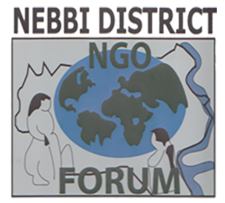
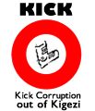
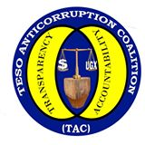
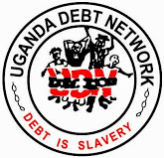
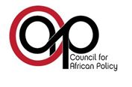
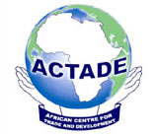
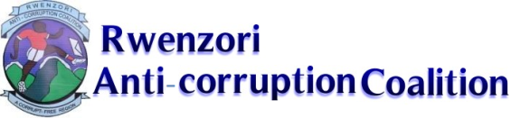

The Civil Society Position Paper on the Opportunities and Challenges to Service Delivery and Budget Implementation was produced by the CSOs under their umbrella Civil Society Budget Advocacy Group (CSBAG) with support from Democratic Governance Facility, Oxfam Uganda, and USAID Uganda and UKAID Uganda Governance, Accountability, Participation and Performance (GAPP) Program. The contents of this publication are the responsibility of CSBAG and not of our development partners.

© 2016

Civil Society Budget Advocacy Group (CSBAG)
P.O. Box 660, Ntinda
Plot 15 Vubya Close, Ntinda Nakawa Rd
Fixed Line: +256-755-202-154
E-mail: csbag@csbag.org
Web www.csbag.org
| @CSBAGUGANDA CSBAG/Facebook.com

All rights reserved. No part of this publication may be reproduced, or reprinted in any form by any means without the prior permission of the copyright holder. CSBAG encourages its use and will be happy if excerpts are copied and used. When doing so, however please acknowledge CSBAG.

Foreword
The development of this position paper was a concerted effort of various Civil Society Organizations (CSOs) under the umbrella of Civil Society Budget Advocacy Group (CSBAG). Although it is not possible to mention all those who made contributions, I would like to recognize the role played by all National and regional Civil Society Organizations that coordinated the regional budget consultations in Northern, Western, Central and Eastern regions. Through their efforts, input into this paper was generated which enriched our position paper on key issues pertaining to improved public finance management and quality service delivery. Altogether 41 CSOs participated in this process (see Annex 3 for all participating CSOs)
CSBAG is grateful to Government of Uganda through the Ministry of Finance Planning and Economic Development for the space it has provided to the Civil Society Organizations to participate in the Regional Local Government Budget Consultative Workshops for the Financial Year 2016/17. Our participation in the budget process guarantees that citizens needs and priorities are addressed, fosters better understanding by the CSOs and citizens of Local Government Planning and budgeting processes as well as other critical information that makes us more effective to influence policy and improve service delivery at the Local Government Level.

It is hoped that this position paper will provide a framework to guide the budgeting process for the FY 2017/18 to ensure that resources at the Local Government are mobilized, allocated and utilized in an efficient, equitable and gender sensitive manner to promote sustainable development.

Julius Mukunda
Coordinator

List of acronyms
BTI Budget Transparency Initiative
CAO Chief Administrative Officer
CBOs Community Based Organizations
CSBAG Civil Society Budget Advocacy Group
CSOs Civil Society Organizations
DCDO District Community Development Officer
DSCs District Service Commissions
DTPC District Technical Planning Committee
FGDs Focused Group Discussions
HC Health Center
HUMCs Health Unit Management Committees
KII Key Informant Interview
LGBC Local Government Budget Consultation
LGs Local Governments
LLGs Lower Local Governments
LST Local Service Tax
MDAs Ministries, Departments and Agencies
MoFPED Ministry of Finance Planning and Economic Development
MoPS Ministry of Public Service
NBFP National Budget Framework Paper
NDP II National Development Plan II
NPA National Planning Authority
O&M Operation and Maintenance
OAG Office of Auditor General
OBT Output Budgeting Tool
OPM Office of the Prime Minister
OTMIS Online Transfer Management Information System
OWC Operation Wealth Creation
PBB Performance Based Budgeting
PEMCOM Public Expenditure Management Committee
PFM Public Finance Management
PPDA Public Procurement and Disposal Authority
RDC Residence District Commissioner
SMCs School Management Committees
TC Town Council
URA Uganda Revenue Authority
WUCS Water User Committees
PBCs Participatory Budget Clubs

Table of content
Contents
Foreword iii
List of acronyms v
Table of content vi
1.0 INTRODUCTION 1
1.1 About the CSO paper 1
1.2 Background 1
2.0 NOTABLE MILESTONES IN PUBLIC FINANCE MANAGEMENT 2
2.1 Improving Budget Formulation and reporting 2
2.2 Direct Transfer of funds to Service Delivery Units and llgs 2
2.3 Strengthening Budget Transparency 2
2.4 Strengthened relations amongst csos, mdas and lgs in budget monitoring work 3
2.5 Increased response to address CSO service delivery concerns Local Government 3
3.0 CHALLENGES TO SERVICE DELIVERY 5
3.1 The staffing challenge 5
3.2 Poor performance of Local revenue mobilisation 7
3.3 Weak state of record management in lgs 8
3.4 Uncoordinated and limited funding for monitoring and supervision in lgs 8
3.5 Inadequate and poor maintenance of infrastructure and equipment to facilitate service delivery 10
3.6 Poor functionality of Accountability Structures at LG Level 11
3.7 Misuse of public resources, shoddy work and non-accountability 12
3.8 Lack of Development Plans by spending agencies & poor alignment of the existent ones to the NDP II 15
3.9 Inadequate local government financing from central government 15
4.0 CONCLUSION 16
ANNEXES 16
Annex 1: Service delivery concerns addressed by duty bearers in 2015/16 16
Annex 2: picture gallery on the service delivery situaton in some of the districts we operate in 18
Annex 3: Civil Society Organisations CSBAG Collaborated with to develop this Position Paper 22

1.0 INTRODUCTION

1.1 About the CSO paper
Under the umbrella of the Civil Society Budget Advocacy Group (CSBAG), various Civil Society Organizations (CSOs) and CBOs across Uganda utilized their accountability structures to consult citizens on how to improve service delivery in their localities. Consultations were held at the Lower Local Governments by Civil Society Organizations operating in the regions of operation in North, East, Central and West. Community Dialogues, Focus Group Discussions (FGDs) and Key Informant Interviews (KII) were held to collect the citizen’s views. To consolidate the issues, we held four CSO regional meetings between the 15th to 18th August 2016 and a two-day national workshop with the Regional CSO clusters that culminated in the development of this CSO issues paper.

1.2 Background
Since 2015, there has been a deliberate effort by the government of Uganda, especially Ministry of Finance, Planning and Economic Development (MoFPED), to increase CSO participation in the planning and budgeting process in Uganda. For the first time, CSOs were invited by Ministry of Finance Planning and Economic Development and allocated space on the programme to make presentations in each of the twenty (20) Local Government Budget Consultative workshops for the Financial Year 2016/17. This greatly impacted on the government efforts in improving accountability and service delivery. It is therefore, not surprising that the International Budget Partnership (IBP) 2015 Open Budget Survey, which assesses the budget transparency of countries in the world, ranked Uganda as 3rd best in Africa; scoring 63% compared to 55% in 2010, where there was no CSO involvement.
Building on this momentum, we continue to engage government, especially MoFPED, on issues of budget performance monitoring and service delivery improvement, through our quarterly engagements, participation in Sector Working Group Meetings and other technical working groups of government.
Alongside this remarkable performance however, the government of Uganda, is still faced with fundamental challenges of enhancing budget performance and improving service delivery. We continue to witness, understaffing, poor quality infrastructure, corruption, poor performance indicators especially in health and education, lack of or limited inspection & monitoring.
The involvement of CSOs in the Local Government Budget Consultative (LGBC) meetings for the FY 2017/18 therefore fits perfectly within the remit of complementing government efforts to improve service delivery and budget performance. As CSOs, we endeavor to provide credible alternative policy options that will assist government in delivering on its mandate.

2.0 NOTABLE MILESTONES IN PUBLIC FINANCE MANAGEMENT

2.1 Improving Budget Formulation and reporting
The Upgrading from the Output Budgeting Tool (OBT) to Programme Based Budgeting (PBB) will enhance budget functionality, alignment to the country plans and reporting. The focus on measurable outcomes rather than processes and outputs will improve the efficient use of national resources; potentially curb funding to poorly performing programmes and increase Ministries Departments and Agencies (MDAs) flexibility in budget implementation. As CSOs we welcome this initiative and call upon MDAs and Local Governments (LGs) to embrace this change to enable us achieve the desired outcomes for propelling the country into middle income status by 2020.

2.2 Direct Transfer of funds to Service Delivery Units and LLGs
We welcome this measure of transferring funds directly to Service Delivery Units and Lower Local Governments (LLGs). This has been a CSO proposal for quite some time and we anticipate that this budget reform will reduce leakages in the transfer system and make service delivery units more accountable. This would then reduce bureaucracy and increase the autonomy of the Sub-counties.

2.3 Strengthening Budget Transparency
We would like to applaud the MoFPED for promoting budget transparency and accountability in Uganda through the implementation of measures like publishing quarterly releases and development of a budget website www.budget.go.ug. Yet again the launching of Online Transfer Management Information System (OTMIS) will provide the citizens of Uganda and CSOs with information that can be used for purposes of monitoring government expenditure and demanding accountability. We would like the LGs to emulate this MoFPED practice by publishing their reports on notice boards to enhance citizen accountability. The recent re-launching of government barazas by the Office of the Prime Minister (OPM) provides additional platforms for CSOs and citizens to effectively engage government especially at LG level on service delivery and budget issues. We look forward to Local Government support in this barazas initiative.

2.4 Strengthened relations amongst CSOs, MDAs and LGs in budget monitoring work
In the FY 2015/16 National Budget Framework Paper (NBFP), the government came out unequivocally and pronounced itself on working with CSOs in budget monitoring and accountability for improved service delivery. We are glad to report that these statements have been actualised and in most cases CSOs have participated in LG planning processes. We are witnessing increased acceptance by LGs to incorporate CSOs on technical planning committees at the District and LLG level.
Spaces such as Public Expenditure Management Committee (PEMCOM), Budget Transparency Initiative (BTI) and Sectoral Committees of Parliament, Sector Working Groups and District Technical Planning Committees (DTPCs) at the District level have greatly enhanced Civil Society and citizens to actively participate in the planning and monitoring of government programs for improved service delivery. This continued open door policy at the national and local government levels has enabled CSOs to access the right information in a shorter time, which has increased the accuracy of advocacy messages we share with the public.

2.5 Increased response to address CSO service delivery concerns Local Government
We are proud to report that the Local Governments of Uganda have continuously adopted and implemented CSO proposals for improved service delivery. For example, in Kibuku District, Kadama HCIII, there was only one functioning pit latrine for patients and staff. After Participatory Budget Clubs (PBCs) members engaging the district over this challenge, the Kibuku district Local Government allocated UGX 15.2m for the pit latrine FY 2014/15 that was completed in May 2015. In Agago district, Paimol S/county, Paimol HCIII had an incomplete Maternity Ward still after PBCs brought the matter to the attention of the sub county and district leadership, the maternity ward was constructed and handed over in 2015. In Sheema District, Sheema Town Council, there was the continuous abscondment by the head teacher of Nyakashombya Primary School. He was transferred in 2015. (See details of other adoptions in attached Annex I). Other examples include improvement in the areas of staffing, timely submission of reports and increased citizen voices in demanding for services and accountability.

Other examples on service delivery challenges effected by Duty bearers in response of citizens demands are illustrated in pictured below:
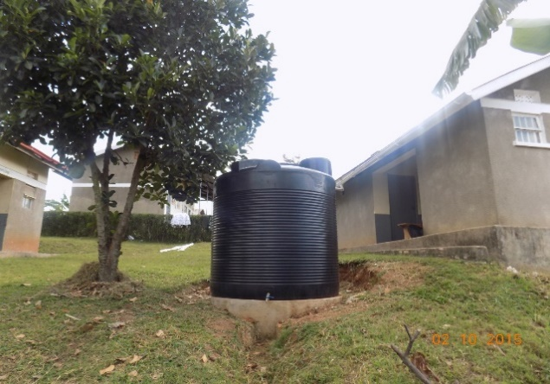
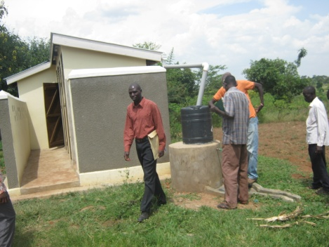
The new water tank installed at Rwamujojo Health Centre II, Sheema Town Council, Sheema District, and July 2015. | © CSBAG, 2015

Community members Supported by CSBAG inspecting a newly constructed pit latrine with WASH facilities at Goli- Goli Primary School in Kibuku district (August 2015). | © CSBAG, 2015

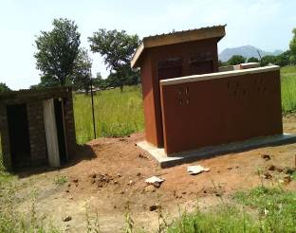
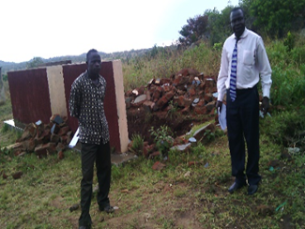
Left: The former CAO, Agago Okaka Geoffrey during the joint monitoring visit to Lira Kaket HC II in November 2014. Right: The newly constructed pit latrine at the HC in July 2015| © CSBAG, 2015

New Latrine 2015
Collapsed latrine 2014

3.0 CHALLENGES TO SERVICE DELIVERY
The budget strategy and priorities for the FY 2017/18 should be informed by the sequencing of priorities of the National Development Plan (NDP) II which is now in its second year of implementation. CSOs keenly follow the public financing of social sectors that have been prioritized in the NDP II, as they have direct impact and are largely depended on by majory the poor and marginalised women and men of Uganda. The following are the key areas of concern that CSOs present that need Government attention:

3.1 The staffing challenge
There is a persistent challenge of understaffing in all service delivery points in Government. For example, the Office of Auditor General (OAG) Report for the FY 2014/15 Vol. 3 revealed that the high level of vacant positions in LGs had not significantly improved. The levels ranged from 14% in Bududa LG to 87% in Luuka Town Council (TC). This has further been compounded by the creation of new districts which strains the poor staffing structure. Key positions like magistrates, teachers, health workers, district engineers and extension workers are still grossly under staffed. Worse still, some of the critical staffs are in acting positions which compromises decision making.
Understaffing is hugely attributed to the limited wage bill and a ban on recruitment by the Ministry of Public Service (MoPS). The issue has recently been put in a new light by the president’s proposal to reduce the civil servants in an effort to improve service delivery. The Public Service Standing Orders make it extremely difficult to discipline errant public servants or retire those who are proved to be incompetent.
Worse still, we still have section of civil servants that hugely affected by delayed salary payment, huge variations in salary among staff at the same Government scale. The Equal Opportunities Commission Annual Report, 2015 revealed that a Permanent Secretary in any government ministry would need to work for 10 years and 9 months in order to be able to get what a Commissioner General of Uganda Revenue Authority (URA) earns in one year. This state of affairs continues to act as a disincentive for good performance in LGs and other MDAs but also precipitates corruption. Furthermore, the existing structure of public service doesn’t resonate with the Vision 2040 aspirations of having government do business like the private sector by having a lean and efficient public staffing structure.
Recommendations
- Ministry of Public Service should review the staffing structure public service with a view to making it lean and efficient.
- There is need to expedite the process of setting up the Salary Review Commission to harmonise public/civil service remunerations in order to reduce the disparities.
- Review Public Service standing orders to enable disciplinary action to be taken against errant public servants instead of just being transferred.

3.2 Poor performance of Local revenue mobilisation
Local Governments receive over 85% of their revenue from conditional grants from the Central Government. A review of revenue performance of 138 councils revealed an under-collection of local revenue amounting to UGX 23.9 Bn. Such a shortfall means that implementation of the planned activities for that particular year was distorted and thus citizens were denied the much needed services. The OAG report 2014/15 attributes this to failure by local government to carry out revenue enumeration and assessments, non-enforcement of contracts with private revenue collectors, incomplete revenue records and understaffing.
Issues around poor management (collection and reporting) of Local Revenue as well as limited monitoring and supervision by the relevant ministries and (or) district departments, further aggravate the already bad situation. There is inadequate effort to collect revenue from the existing and potential sources of revenue e.g property tax, market dues, Local Service Tax (LST) and loading fees (produce stores). For example, in Mubende district, the livestock market called Kisita in Kitumbi Sub-county is not fenced and as some result potential tax payers easily escape the market premises without paying tax. Also, the issue of royalties has not been fully exploited and utilised to benefit the LGs. For example, in Kabale, the iron ore and wolfram mining companies have continuously gone without remitting royalties to the LG.
Recommendations
- LGs should conduct a comprehensive assessment of Local Revenue sources and their potential so that they can have a district local revenue data base.
- A mechanism needs to be instituted to curb non remittance of collected revenue and issuance of counterfeit receipts. This would also call for strict supervision by the district revenue officer and head of Finance Department.
- URA should build capacity of Local Governments with an aim of contracting them to collect revenue on a commission basis.
- LGs should sensitise tax payers on paying taxes and linking it to delivery of services.

3.3 Weak state of record management in LGs
Proper record keeping and management is an important component and a cornerstone in the promotion of open budget systems and improved transparency and accountability. Without proper record keeping and archive management, mismanagement of resources, uninformed decision making and operational failure can escalate. According to the Budget Monitoring and Accountability Unit (BMAU) Briefing Paper 13, there is insufficient storage space in LGs, District Service Commissions (DSCs) and Urban Authorities. For example, there are no registries and records centres in Town Councils (TCs) and DSCs in Manafwa, Nwoya and Rubirizi Districts.
Picture 1: Poor state of record management in Bulambuli District, Picture Courtesy of BMAU Briefing Paper 2015. | © Budget Monitoring and Accountability Unit (BMAU), 2015

Recommendation:
- Local governments should make deliberate efforts to secure storage space for records to enhance transparency and accountability.

3.4 Uncoordinated and limited funding for monitoring and supervision in LGs
A review of the LG performance report for the FY 2015/16 revealed that the inspection and monitoring function is greatly underfunded with only 4.692 bn as approved budget for inspecting 18,408 schools (pre-primary and primary).This has greatly affected the functionality of service delivery centres. Cases of absenteeism are rampant in schools and health centres among teachers and health workers respectively. In some instances, infrastructure projects are poorly implemented or abandoned due to lack of inspection by the relevant officers. In Alebtong district, Omoro Sub County, Angicakide P/S which was established in 1989 only runs classes up to P6 yet it receives the UPE grant every term. Further interrogation of the matter revealed that it was a case of lack of inspection and monitoring of the school by the relevant officers that hampered its progression up to P7.
In Nakasongola district for example, the office of District Community Development Officer (DCDO) has no motorcycle. This has negatively impacted on effective supervision. In Mubende district, the District Finance Committee discovered potential sources of revenue un-assessed in the gold mining sub county of Kitumbi. Further interrogation of the issue revealed the Revenue Officer lacked facilitation for inspecting the revenue potential in the sub county.
Due to limited facilitation of inspection in the Production and Marketing Department, the Agriculture Officers do not monitor and inspect the Operation Wealth Creation (OWC) distribution of inputs, often leading to wastage. In June 2016, Lira district received 109 heifers and 20 died in two days due to lack of inspection by the agriculture officers hence not giving guidance to the OWC team and the famers regarding the handling the animals.
There is also the problem of the existence of so many un-coordinated monitoring and supervision centres e.g. government performance assessments by Ministry of Local Government, Office of the Prime Minister (OPM) through Barrazas, Economic Monitoring Unit and Health Services Monitoring Unit as well as Resident District Commissioners (RDCs). At any one time a district receives monitoring missions from different central government entities in the same period over the same issues thus highlighting poor coordination.
Recommendation
- In the FY 2017/18 Government needs to provide more funds for the critical function of supervision and monitoring of service delivery centres like schools and health centres to improve functionality and reduce on absenteeism of staff.
- Harmonise the inspection function at the national level say under Office of the Prime Minister and operationalise the District Integrity Promotion Forum coordinated by the Directorate of Ethics and Integrity, chaired by the Residence District Commissioner (RDC) and the Chief Administrative Officer (CAO) as secretary, to coordinate inspection and monitoring in districts.

3.5 Inadequate and poor maintenance of infrastructure and equipment to facilitate service delivery
For service delivery to be effective, a number of supporting rural infrastructure facilities need to be in place and well maintained. These include, classroom blocks, clean and safe water sources, access roads, sanitation facilities including toilets, placenta pits, incinerators at Health centers among others. Often time, this is not the case for many LGs. A case for inadequate water services is in Mubende district where safe water coverage is currently at 42.8%(OAG Report, 2015), far below the national rural access of clean water average of 65%. Other social indicators reveal glaring gaps between the national standard and the prevailing ratios. Another example of inadequate service delivery facilities/equipment is in the health and education sectors According to the Mubende District Local Government Report, 2016 the Pupil Classroom ration was at a ratio of one classroom housing 75 pupils against the standard of one classroom for 55 pupils. The other example is of 1 desk accommodating 6 pupils against a standard of 3 pupils per desk and lastly is the latrine stance ratio, generally in Mubende one latrine stance serves 140 pupils against a standard of 50 pupils per 1 latrine stance.
Furthermore, in Apederu Primary School in Amuria district, pupils are still studying under trees.
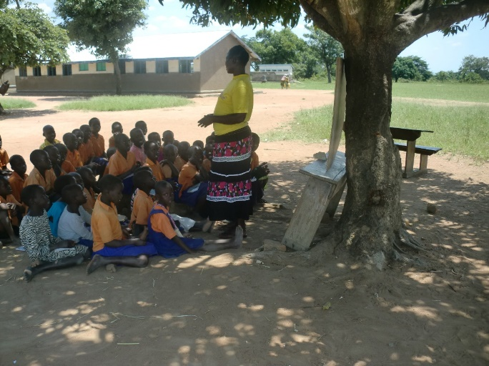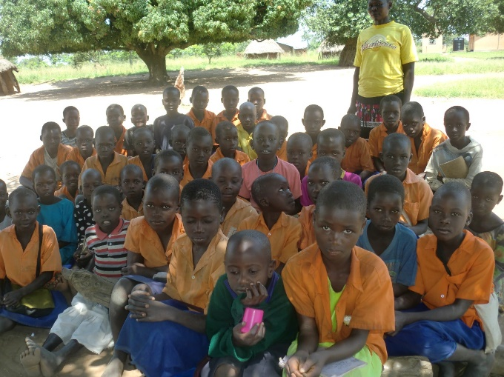
Picture 2: Teaching in progress under a tree in Apeduru Primary School in Amuria District. | © Teso Anti-Corruption Coalition (TAC), 2015
Such inadequacies result into overcrowding for a given facility and in the long run have implications on the learning abilities and outcomes for Ugandan children.Table 1: a snapshot of school infrastructure in Mubende district
Description | Current | Standard
Pupil classroom ratio | 1:75 | 1:55
Pupil to desk ratio | 1:6 | 1:3
Pupil to Latrine stance ratio | 1:140 | 1:40
Source: Mubende District Local Government 2016
for health centres, Kapelebyong HC III in Kapelebyong Sub-county, Amuria district, 6 staffs share one house. The same health center has no ambulance to support referrals.
In Maanyi HCIII in Maanyi SC, Mityana district serves many other Sub-counties, yet there is no accommodation for the health staff, the mid wife sleeps in the store within the HC ward. Failure to provide and maintain these facilities is a key indicator for poor service delivery.
Recommendations
- Provide adequate resources to address the challenges pointed out above which would lead to improved service delivery.
- Adequate provision need to be made in the Budget for FY 2017/18 for Operation and Maintenance of Infrastructure in Health, water, roads and Education

3.6 Poor functionality of Accountability Structures at LG Level
To ensure efficient management of public resources, Government of Uganda instituted structures like Senior Management Committees (SMCs) Health Unit Management Committees (HUMCs), Water and Sanitation User Committees among others. These structures are instrumental in enabling sustainable use and management of public resources and assets and therefore their functionality is very critical.

A review of the functionality of these structures has shown that many are non-existent at public facilities where they should be and those that are existent are grappling with a number of challenges that include their constitution, administration and accountability to the community. For example, the Water User Committees (WUCs) do not fully account for the money collected to maintain the water points. According to the MWE SPR 2015, only 23% of WUCs make timely contribution towards Operation and Maintenance (O&M) of water facilities due to the mismanagement of funds by these user committees and poor record management. As a result, citizens are increasingly declining to contribute money and effort for maintenance leading to the limited functionality of water points like boreholes.

Similarly, in the education and health sectors, School Management Committees (SMCs) and HUMCs are constituted by community members who cannot read or write but yet tasked with approving budgets, work plans and reports of and work plans of these schools and health centres.

Recommendations:
- Deliberate effort should be made to build capacity of facility management committees so that they can effectively perform their roles.
- As part of their performance contracts, accounting officers should report on the functionality of these management committees.

3.7 Misuse of public resources, shoddy work and non-accountability
Service delivery has continued to be compromised through substandard works (shoddy works) which are either duly certified or paid for or left not acted upon despite being reported by community members, CSOs, Inspectorate of Government or the Auditor General. The Auditor General’s Report 2014/15 has also slammed a number of Local Governments for poor accountability for public resources and has demanded for remedial actions which oftentimes are not forthcoming. See Picture 3 for more on this.
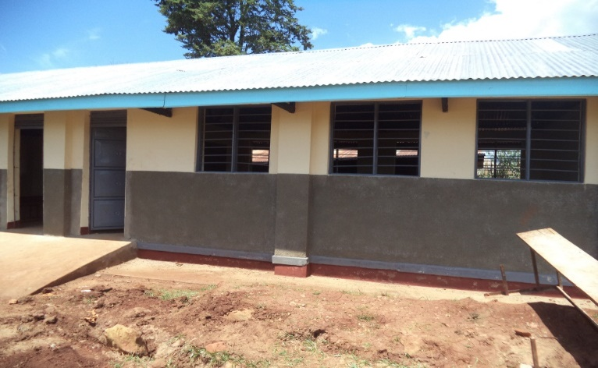
Cracked wall of newly constructed classroom Block
Picture 3: A Classroom block in Kaplegeb P/S in Kween District which looks good from far but far from good in the inside. | ©SD-CODE, 2015
In the audit period of FY 2014/15, the Auditor General’s reports indicate the following findings about the Teso districts: Projects worth UGX 1.2Bn were incomplete by the end of the financial year due to a number of factors including poor contract management; UGX 40M was unaccounted for by the end of the financial year 2014/15; and UGX 140M worth of wasteful expenditure in purchase of idle equipment and in implementation of unnecessary projects.
Other examples include the Low Cost sealing of Katakwi Toroma Road at 479,393,280/= and the Raising of Ongongoja Swamp at 95,261, 000/=. In Kaberamaido District, the Auditor General report for the financial year ending June 30th 2015 noted 5 projects worth 295,508,467/= which were either incomplete or had works that were classified as shoddy.
During the CSO service delivery monitoring exercises in 2015, one of the major issues they uncover revolve around mismanagement of funds especially in schools. For example, in the Teso sub region, Most of the UPE schools Teso Anti-Corruption Coalition (TAC) monitored never kept any basic books of accounts. In Ongatunyo Primary School, Toroma Sub County of Katakwi District the Head Teacher misappropriated UGX 3M meant for UPE grants; while in Ongoromo Primary school, Anyara Sub County of Kaberemaido, the parents accused the former Head Teacher of misappropriation of funds amounting to UGX 39M. Some of the cases on poor pulic fiancé management are best illustrated in the image below:
Source: Civil Society Budget Advocacy Group Resource tracking Report, 2013-2015
Recommendations:
- Parliament should constitute itself into special committees to enforce recommendations from the Auditor General’s Reports on what???
- Increase funding for the OAG and the PPDA to adequately cover all MDAs and local governments. Currently only 1168 government institutions are audited and 618 are not. The audit of 1189 sub-counties for the FY 2014/15 remains outstanding due to lack of funds. Less than 30% of government institutions are audited by PPDA.

3.8 Lack of Development Plans by spending agencies & poor alignment of the existent ones to the NDP II
In accordance to Sec 13 (7) of the Public Finance Management Act, 2015, the National Planning Authority (NPA) submitted the Certificate of Compliance to the FY 2015/16 budget for various Ministries, Departments and Agencies (MDAs) . The findings by the NPA revealed that the FY2015/16 Annual Budget was 68.3% compliant to the NDP II. This overall assessment is an average performance at the three broad levels; at the Macro level - 72.3 %, National Strategic level - 75.4 % and at Sector and MDA level - 57.7 % compliant. The analysis of 17 sectors revealed that only 8 have Sector Development Plans, of which, only 3 are aligned to the NDPII in terms of both focus and timeframe. In addition, most MDAs did not have Strategic Plans. This is unacceptable as it will lead to wastage of public resources.
Recommendations:
- Government should not approve budgets for any agency that does not have a strategic plan

3.9 Inadequate local government financing from central government
Local Governments are at the forefront of service delivery in Uganda. Unfortunately, because of low funding the performance of key sectors sectors like agriculture, education, health and water remain extremely low. Whereas government is providing resources for salaries it is also imperative government provides adequate resources for non-wage and development expenditure to achieve the desired service outcomes. For example, in the first quarter of FY 2016/17 the 8 Teso Districts received UGX 36Bn of which 75% designed to cater for the wage component and the balance is shared between non-wage and development expenditure. Due to funding shortfalls; crucial actions like monitoring of service delivery, functionality of statutory institutions and oversight functions insufficiently catered for.
Recommendations:
- LGs should be given at least 30% of the national budget so as to put to implementation the critical actions necessary for development service delivery and problem solving. More resources need to be allocated to cater for non-wage and development expenditure at local government level.

4.0 CONCLUSION
This Position paper highlights the key milestones in public finance management made by the Government of Uganda. It also shows progress made by Local Governments in responding by addressing key to service delivery concerns as highlighted by citizens, as seen in the specific reports from the districts. It is our prayer that the recommendations made in this paper are taken up by Government to improve accountability and service delivery to enhance citizen satisfaction.

ANNEXES

Annex 1: Service delivery concerns addressed by duty bearers in 2015/16

Sub county | NAME OF SERVICE DELIVERY CENTRE | SITUATION BEFORE | STATUS TO DATE
KIBUKU DISTRICT
KADAMA | Kadama HCIII | There was one functioning pit latrine for patients and staff. | The local government allocated UGX 15.2m for the pit latrine FY 2014/15 that was completed in May 2015.
 |  | Lack of general ward | New general ward was allocated UGX 120m to be constructed between FY 2014/-FY 2015/16.The ward is currently in its last phase comprised of equipping at a cost of UGX74m.
BUSETA SUB-COUNTY | Buseta HCIII | Need for another pit latrine | Pit latrine has been prioritized for construction at the HCIII for the FY 2016/17
 | Buseta- Kameme community access road | Impassable community access road | The road was completed in June 2015 and commissioned in July 2015
 | Moru primary school | Completion of the construction of pit latrine at Moru Primary School | The construction of the pit latrine was completed and the work was commissioned in July 2015
Kagumu sub county | Nakibenge spring well | The spring well was unprotected and shared by humans and animals which paused health risks | Spring well was protected in 2016
AGAGO DISTRICT
PAIMOL | Locum primary school | Absent of female teacher in the school | One female teacher was posted by the District in December 2015
 | Paimol Health center III | Incomplete maternity ward | Maternity ward was completed and handed over for use in October 2015.
LAPONO SUB COUNTY | Ajali Lajwa PRIMARY SCHOOL | No staff house in the teacher quarters | This is provided for within the five year Lukole sub county development plan for 2016/2017(pg. 67)
 |  | There is only six classroom block leaving a gap of One more classroom | This is provided for within the five yeas Lukole sub county development plan (pg. 67)
 | Lapirin H/C II | The health facility is serving seven sub counties, yet it is providing basic health services as a health centre II | The facility was upgraded from H/C II to health center III in September 2015
KIBAALE DISTRICT
RUTEETE SUB COUNTY | Ruteete Primary School | Dilapidated pit latrine | Construction of pit latrine commenced in July 2015
SHEEMA DISTRICT
SHEEMA TOWN COUNCIL | Rwamujojo H/CII | Lack of water source at H/C | Installation of Water harvesting tank in August 2015
 | Nyakashambya Primary School | Continuous abscondment by the head teacher | Transferred in 2016
 | Kamabare Primary School | The School was not fenced | The process of fencing was completed in June 2016
KASAAANA  SUBCOUNTY | Rukondo Health Centre II | Absenteeism and Arrogance of Health Centre In Charge | Transferred to District for direct supervision in 2014 and later to Kabwohe H/C IV in 2016.
 | Kasaana East H/C II | Un fenced premises of the H/C. | Fencing completed in the Months of August 2015
 | Ruhigana Primary School | Incomplete Staff House that had stayed for almost 2 years | 2 Rooms Staff house Completed with allocation of UGX 1,939,000 in August 2015
 | Mishenyi Primary School | In Active School Management Committee Members | A new active Committee appointed on 18th September 2015.
ABIM SUBCOUNTY
ABIM SUB-COUNTY | Oryeotyene primary school | No kitchen at the school, pupils food being prepared under trees | A new kitchen and store attached was constructed in the school at a cost of 15m UGX in July 2015
 | Kanu primary school | No modern kitchen | The sub-county has awarded a contract for construction valued at UGX18m for the construction of a kitchen and store in July 2015
 | Kanu Primary School | School latrine used by school gals as a bathroom | Bathing shelter was constructed in 2016
 | Access road to Abim sub county offices | Delays in clearing the community access road to Abim sub-county office | The road was cleared in August 2015.
ALEREK SUB-COUNTY | Koya primary school | Absence of a permanent staff house | A two staffs block house was constructed at the school in July 2015
 | Alerek primary school | No latrine for boy at the school, the one being used was full | A four stance pit latrine at UGX 16m is going to be constructed in FY 2016/17
MORULEM SUB-COUNTY | Rachkoko primary school | Incomplete construction a two class room block | The class room construction was completed
 | Akwangagwel primary school | The school lacked desks causing pupils to sit down | 56 three sitter desk/benches was supplied to the school in August 2015
Source: CSBAG Service delivery tracking report, 2015

Annex 2: PICTURE GALLERY ON THE SERVICE DELIVERY SITUATON IN SOME OF THE DISTRICTS WE OPERATE IN
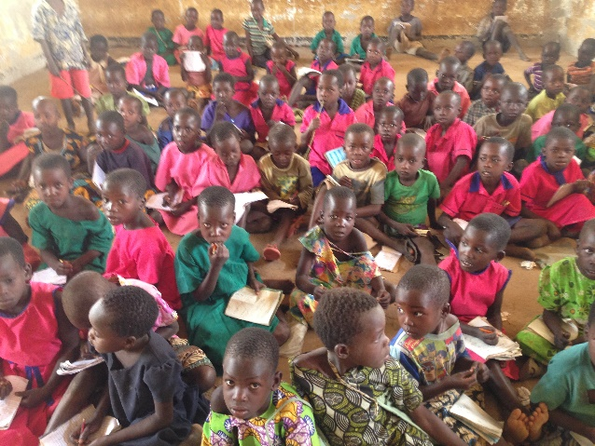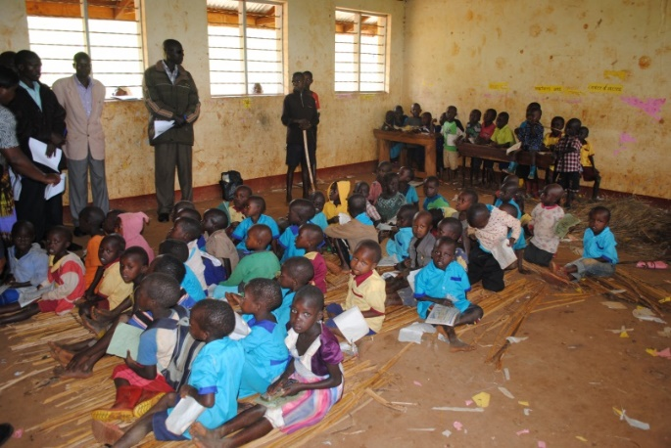
Picture 4: (Left) Pupils of Takaramiem in Gweri in Soroti and (those) those in Chemonsong P/S in Chema S/C Kapchorwa study without desks. | ©SD-CODE, 2015
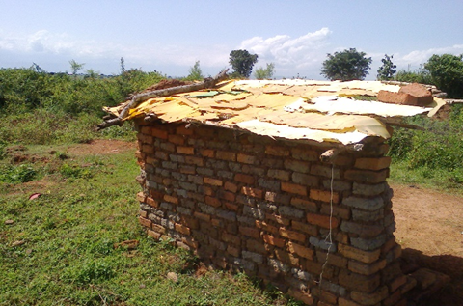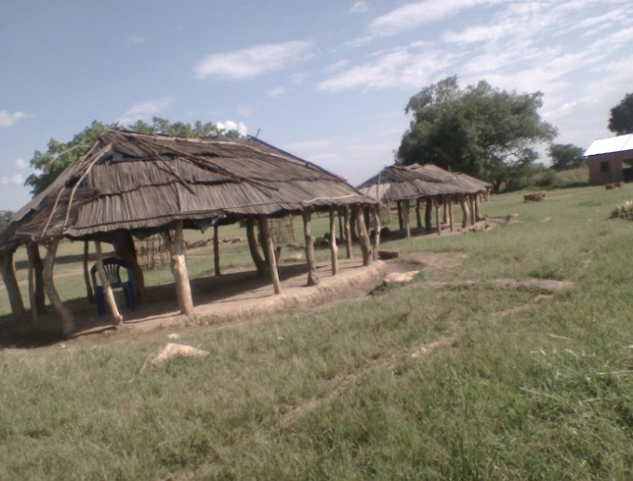
Picture 5: A pit latrine at Kacage PS in Bukedea District and A classroom at Aep PS kateta Serere District. | ©TESO ANTI CORRUPTION COALITION, 2015
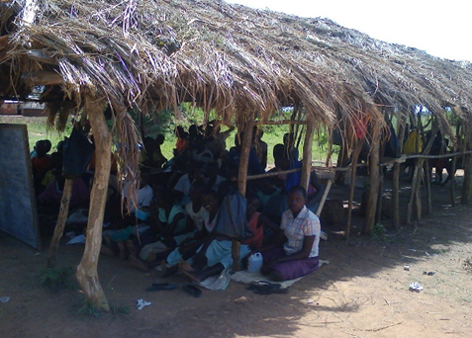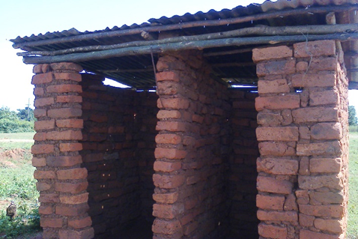
Picture 6: A class in Kacage Primary Sch Bukedea District on the Left, while (right) a pit latrine in the same school. | ©TESO ANTI CORRUPTION COALITION, 2015

Poor infrastructure in Gotcam Primay School in Zombo District
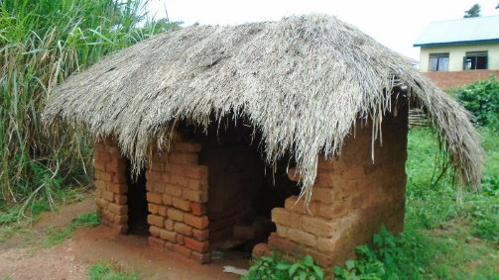
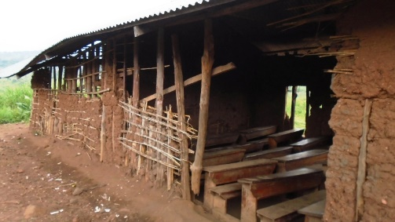
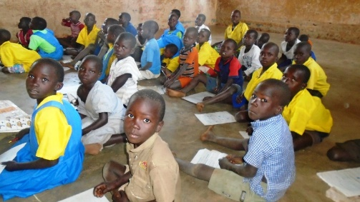Pupils of Gotcam Primary School siting on the floor because of lack of desk whose picture (CSO)
Left is a classroom block and right is a boy larine stance at Gotcam Primary school whose picture (CSO)

Infrastructure gaps in Kapchorwa, Kween and Bulambuli districts
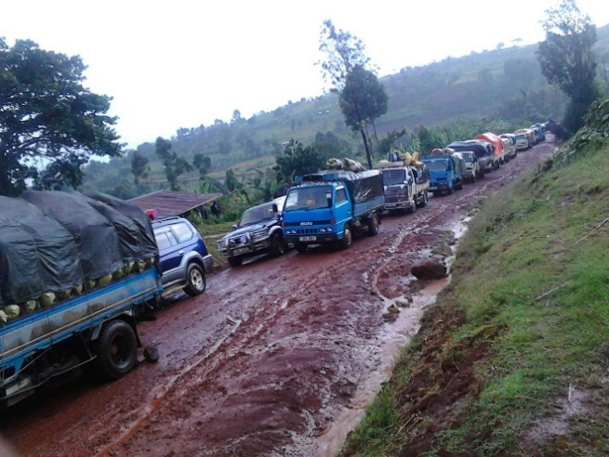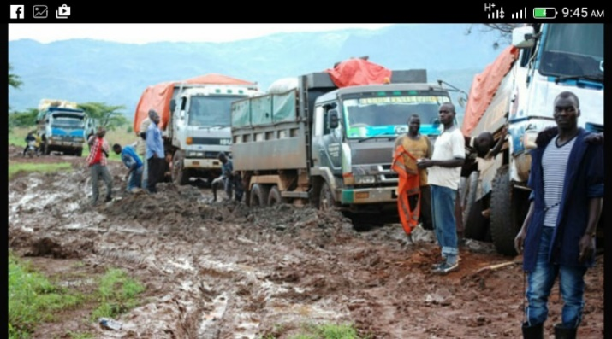
Kapchorwa, Kween to Bukwo Road Bulambuli Kween to Nakapiririt road
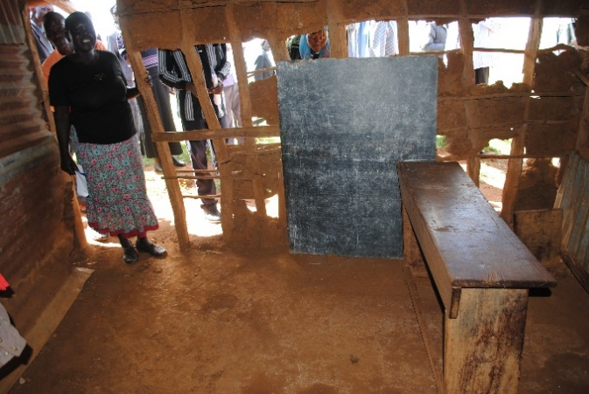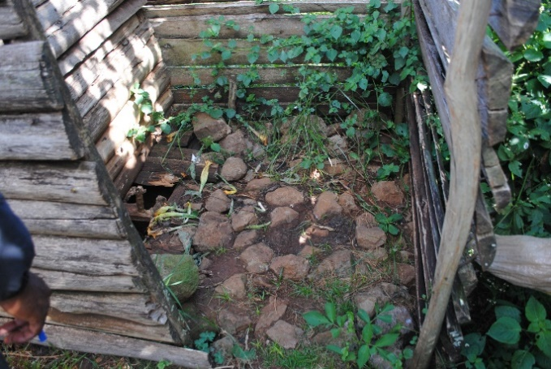
A classroom in Kitiwoi P/s, Kitowoi S/C Kween district. Sanitary facilities for the girl child | ©SD-CODE, 2015

ANNEX 3: CIVIL SOCIETY ORGANISATIONS CSBAG COLLABORATED WITH TO DEVELOPM THIS POSITION PAPER

Central region

Region | Name | District /headquarters
Central Region
 | Southern and Eastern Africa Trade Information and Negotiations Institute (SEATINI) | National
 | UgandaNational NGO-Forum- | National
 | SORAC-Development Agency | Mubende
 | Transparency International Uganda (TIU) | National
 | Action for Community Development (ACODEV) Uganda | National
 | Women and Girl Child Development Association(WEGCDA) | National
 | Centre for Health Human Rights & Development (CEHURD) | National
 | African Youth Development Link (AYDL) | National
 | Forum for Women in Democracy (FOWODE) | National
 | Uganda Debt Network (UDN) | National
 | Uganda Roads Support Sector Imitative (URSSI) | National
 | Save the Children in Uganda | National
 | Kalangala NGO Forum | Kalangala
Northern Region
 | Lira NGO-Forum | Lira
 | Global Support Development Initiative Uganda | Lira
 | Pader NGO-Forum | Pader
 | Kitgum NGO Forum (KINGFO) | Kitgum
 | Transparency International-Uganda | National
 | Gulu NGO-Forum | Gulu
 | The Apac Anti-Corruption Coalition (TAAC) | Apac
 | Nebbi-NGO-Forum | Nebbi
 | Arua NGO Forum | Arua
 | Moyo NGO Forum | Moyo
 | Lira Diocese Media Limited | Lira
Eastern Region
 | Teso Anti-Corruption Coalition (TAC) | Soroti
 | Public Affairs Centres (PAC) | Soroti
 | Kumi Network of Development Organisation (KUNEDO) | Kumi
 | Council for African Policy (CAP) | National
 | Forum for Women in Democracy (FOWODE) | National
 | Teso Initiative for Peace(TIP) | Kumi
 | Church of Uganda-Teso Diocese Planning and Development office (COU-TEDDO) | Soroti
 | Teso Religious Leaders Efforts for Peace and Reconciliation (TERELEPAR) | Soroti
 | Soroti Catholic Diocese justice and peace commission (SOCAJAPIC) | Soroti
 | Katakwi District Development Actors Network (KADDAN) | Katakwi
 | Friends of Christ Revival Ministries(FOC-REV) | Busia
 | Sebei Dioceses for Community Development (SD-CODE) | Kapchorwa
Western Region
 | Rwenzori Anti-Corruption Coalition (RAC) | Kabarole
 | Kanungu Community Efforts for Rural Transformation (KACOERT) | Kanungu
 | Uganda Debt Network (UDN) | National
 | Kamwenge Development Centre (KDC) | Kamwenge
 | Karambi Action for Life Improvement (KALI) | Kamwenge/Kasese
 | Kabarole NGO and CBO Association (KANCA) | Kabarole
 | Kick Corruption out of Kigezi (KICK) | Kabale
 | Kibaale District Civil Society Organisations' Network (KSCON) | Kibaale

Civil Society Budget Advocacy Group (CSBAG)
P.O. Box 660, Ntinda
Plot 15 Vubya Close, Ntinda Nakawa Rd
Fixed Line: +256-755-202-154
E-mail: csbag@csbag.org
Web www.csbag.org
| @CSBAGUGANDA CSBAG/Facebook.com

CSBAG is a coalition formed in 2004 to bring together CSOs at national and district levels to influence government decisions on resource mobilization, allocation and utilization for equitable and sustainable development.
SORAK, TAC, TAAC, RAC, FOCREV, KICK, SEATINI, UDN, ACTADE, NGO FORUM, ACODE, TI, LIRA NGO FORUM, SDCODE, AYDL, URSSI, WEGCDA, FOWODE, UWASNET, PADER NGO FORUM, GULU NGO FORUM, KACOET, JENGA AFRIKA and CAP.
Men, women, youth, the elderly and Persons with Disabilities (PWDs)
Religious leaders, Community elders, Civil Society, Academia and private sector players among others
Such as Works & Transport, Energy, Accountability, Agriculture and Water & Environment
PBCs are community groups that regularly monitor service delivery at community level and engage duty bearers seeking redress for any service delivery leakages identified
Agriculture, Water and Environment, Health, Education, Social Development and Natural Resources among others
BMAU Briefing of May 2015
Kapelebyong HC III was upgraded to HC IV but has received relevant facilitation for the upgrade
Ministry of Water and Environment Sector Performance Review Report 2015
NPA Certificate of Compliance FY 2015/16
Soroti, Katakwi, Amuria, Ngora, Bukedea, Kumi, Kaberamaido and Serere

