

THE REPUBLIC OF UGANDA

MINISTRY OF HEALTH

Sector Grant and Budget Guidelines to Local Governments

“PHC Development Grants”

FY 2018/19
Table of Contents

Table of Contents 1

1 Introduction 3

1.1 Purpose of the Guidelines 3

2 Structure and Purpose of Primary Health Care Development Grants 4

3 Grant Allocation Formulae 5

4 Budget Requirements and Guidelines for PHC Development Grants 7

4.1 Budgeting for Activities under the Transitional Development - Sanitation

(Health) Grant 7

4.2 Budgeting for Transitional Development Ad Hoc Health Grant 7

4.3 Budgeting for Health Development Grant (IGFT Funds) 8

4.4 Priority for health facility infrastructure 8

4.5 The National Health Facility Availability Standards 9

4.6 Guideline on the Basic Health Infrastructure Requirements 9

4.6.1 Positive & Negative Capital Investments 10

5 Procedures for Health Development Budget Execution 12

5.1 Environmental and Social Screening of Projects 12

5.2 Procurement procedures: 13

5.3 Roles of LGs and MoH in the Procurement of Construction Contractors under

the UgIFT Programme for Results. 13

5.4 Construction Supervision by LGs 15

5.5 Development Projects Progress Reports 17

5.6 Payment Procedure for the works executed / supplies: 17

5.7 Monitoring: 17

6 Annexes 18

6.1 Annex I: Indicative Planning Figures for FY2018/19. 18

6.2 Annex II: Break Down of Health Development Grant (IGFT) & Health Facilities

For Upgrade in FY2018/19 23

6.3 Annex III: Transitional Development Health Ad Hoc Beneficiary Health

Facilities for FY2018/19. 31

6.4 Annex IV: LG Health Performance Measures for Assessment in FY 2018/19 32

6.5 Annex V: Outputs and Indicators 34

1
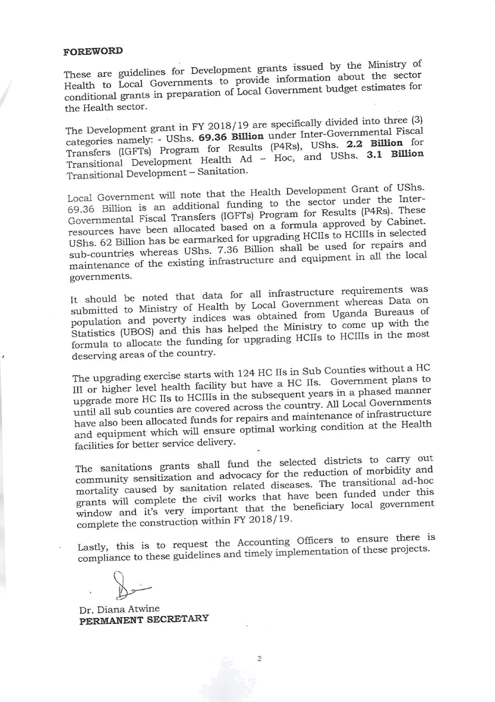
- Introduction

These guidelines are issued by the Ministry of Health (MoH) to Local Governments (LGs) to provide information about the sector conditional grants and guide the preparation of LG budget estimates for the Health sector. They give details of (i) the national policies for the sector, (ii) the role and mandate of Gs in the sectors, (iii) an overview of Central Government grants to LGs, (iv) an explanation of how these are allocated to each LG, and (v) requirements that LGs must follow when preparing the budget.

1.1 Purpose of the Guidelines

This document is to provide guidance for the budgeting and utilization of the Primary Health Care (PHC) grants and other decentralized health grants in Financial Year (FY) 2018/19. These guidelines should be used to prepare and implement annual work plans for both Public and Private-Not-For-Profit (PNFP) facilities as well as Private Health Provider facilities where feasible / desirable.

Financial Management and Accounting procedures should be guided by the Public Finance Management Act 2015, LG and Accounting regulations 2007, the Public Procurement and Disposal Act (PPDA) 2014 and any other guidelines as approved by the MoH.

3
- Structure and Purpose of Primary Health Care Development Grants

Health Sector Development Grants are provided to LGs in order to achieve UHC with emphasis on access, quality and affordability aspects. The structure and purpose of the health sector development grants is shown in Table 1 below.

Table 1: Structure and purpose of PHC Grants

Grant Purpose

Transitional Development – |  |  | Funds sanitation related activities such as
Sanitation |  |  | community sensitizations and advocacy work
 |  |  | that contribute to the reduction of morbidity and
 |  |  | Mortality rates from sanitation-related diseases.
Transitional Development – |  |  | This will continue to fund hospital rehabilitation
Ad Hoc |  |  | and other specified capital investments in
 |  |  | selected LGs.
 | Upgrading of |  | In FY 2018/19, this will fund the Upgrading of
 | HCIIs to HC |  | HCIIs to IIIs in the Sub Counties with no HC IIIs
Health | IIIs |  | But have HCIIs.
Development
(IGFT) Grant | Maintenance |  | In FY 2018/19, this will finance repairs and
 | of Health |  | maintenance of health infrastructure and
 | Infrastructure |  | Equipment in public health facilities.

4
- Grant Allocation Formulae 3.1 Introduction

The Government of Uganda (GoU) with support from the World Bank is implementing the Inter-Governmental Fiscal Transfers (IGFTs) Program for Results (P4Rs).

The key objective is to enhance adequacy, equity and efficiency of financing of decentralized social services thereby improve service delivery outcomes.

The World Bank will support the implementation of the program by providing additional funding of approximately UShs. 200 Billion to support annual increases in recurrent and development conditional grants for health services from 2018/19 to 2021/22.

The disbursement of program funding will be linked to the achievement of results related to improving targets and equity of the grant allocations based on an objective allocation formula and implementation of the LG performance assessment system.

3.2 The Allocation Formula for Development Grants

Under the IGFT P4R, UShs. 69.36bn has been allocated for infrastructure development in the health sector in FY 2018/19.

In line with the second NHP, and as directed by His Excellency the President, the health sector will focus its efforts towards establishing a functional HC III per Sub County across the country in the medium term.

In FY 2018/19, the sector priority is to upgrade HC IIs to IIIs in Sub Counties without a HC III or higher level health facility. Currently, there are 331 Sub Counties with no HC III but have a HC II that can be upgraded. The above funding will be utilized to upgrade over 124 HC IIs to IIIs and the rest shall be upgraded in the subsequent years in a phased manner.

The IPFs for Health Development Grants for FY 2018/19 and the selection of health facilities for upgrading from HC II to HC III (see Annex II) were generated based on the allocation formula in Table 2 below.

5
Table 2: Health Development Grant Allocation Formula (starting FY 2018/19)

Variable Weight Justification

LGs with LLGs without HC | 72 | This is an indicator of demand for
IIIs, but with HC IIs |  | health infrastructure as indicated in
 |  | the Government policy and the scale of
 |  | Services required.
LGs with population larger | 18 | This is an indicator of the degree to
than 87,000 in LLGs without |  | which Local Governments are lagging
HC IIIs, but with HC IIs |  | behind in terms of access to a major
 |  | Health facility.
Number of public HC IIIs, HC | 10 | An allocation to cater for the
IVs and Hospitals |  | maintenance of health infrastructure in
 |  | The Local Governments.

The above parameters/ variables and weightings were applied to generate the Indicative Planning Figures (IPFs) for FY 2018/19 with the aid of the Online Transfer Information Management System (OTIMS) of Ministry of Finance, Planning and Economic Development (MoFPED).

However, effective FY 2019/20, the development grant allocation formula will have two components: (i) the basic component allocated based on the basic allocation criteria i.e. 50% of the grant; and (ii) the performance component based on the results of the LG performance assessment system i.e. 50% of the grant.

3.3 Performance component of the allocation formula

The impact from the results of the assessment will be weighted (scaled) with the basic allocation formula to ensure that every performance indicator has a noticeable impact on the actual size of the allocations, and that the system provides incentives for all (larger as well as smaller LGs). The system will ensure that LGs with a performance score above the average score will receive additional funding and a LG with a score that is below the average will be allocated minimal resources. The system also ensures that all the funds are allocated (no balances). The details have been programmed in OTIMS which is a function of National Budgeting Tool i.e. Program Budgeting System (PBS).

The summary of the health performance measures and the corresponding score points is illustrated Annex IV.

6
- Budget Requirements and Guidelines for PHC Development Grants

In order to access conditional grant funding, LGs are required to adhere to a number of specific requirements relating to the budget allocation and utilization guidelines. These are specified in the following sections;

As per the decentralization policy, the LGs are responsible for planning, procurement and construction of health infrastructure investments. These guidelines should apply to decentralized health infrastructure construction irrespective of funding source.

The MoH will remain responsible for formation of policies, setting national standards, providing guidelines, offering support supervision and monitoring outcomes within the context of Minimum Quality Standards.

4.1 Budgeting for Activities under the Transitional Development - Sanitation (Health) Grant

This development grant shall be allocated centrally and annually to LGs that are implementing the Uganda Sanitation Fund (USF) programme.

The IPFs for Sanitation Grant – Health for FY 2018/19 provided for the LGs which shall implement the programme are attached as Annex I.

The grant should fund sanitation related activities such as community sensitizations and advocacy work that contribute to the reduction of morbidity and mortality rates from sanitation-related diseases.

Refer to the USF implementation Guidelines FY 2018/19 for details.

4.2 Budgeting for Transitional Development Ad Hoc Health Grant

The guidelines for the utilization of the Transitional Development Ad Hoc Health Grant are as follows;

Allocations to health facility infrastructure development, rehabilitation, upgrading, or construction must be at least 95% of the Health Development Grant allocations.

At most 5% should be used for monitoring and supervision of the project

A LG must provide a detailed project profile and work plans for the projects to be undertaken in FY 2018/19.

LGs must follow the MoH guidelines on upgrading and accreditation of health facilities.

7
A LG must receive written authorization from MoH before budgeting for a new health facility to be constructed, or an existing one to be upgraded.

4.3 Budgeting for Health Development Grant (IGFT Funds)

4.3.1 The guidelines for the utilization of the Health Development Grant allocation for Upgrading of HCIIs to HCIIIs are as follows;

At least 98% of the allocation for upgrading of health facility infrastructure should be used for civil or construction works.

At most 2% of the allocation for upgrading of health facility infrastructure should be used for monitoring and supervision of the project.

A LG must provide a detailed project profile and work plans for the projects to be undertaken in FY 2018/19 before commencement of the civil works.

LGs must follow the MoH guidelines on upgrading and accreditation of health facilities.

A LG must receive written authorization from MoH before budgeting for a new health facility to be constructed, or an existing one to be upgraded.

4.3.2 The guidelines for the utilization of Health Development Grant allocation for infrastructure maintenance are as follows;

Allocations to health infrastructure maintenance should be used for repairs and maintenance of health infrastructure and equipment in public health facilities.

The work plan and Priced work schedules must be submitted to Ministry of Health for approval before works are undertaken.

4.4 Priority for health facility infrastructure

In the medium term, as directed by His Excellency the President, the health sector will focus its efforts towards establishing a functional HC III per Sub County across the country. These capital investments will be implemented using the Health Development Grant in the following priority order;

In FYs 2018/19 & 2019/20, the priority will be to upgrade HC IIs to IIIs in Sub Counties without a HC III or higher level health facility. Currently, there are 331 Sub Counties with no HC III but have a HC II that can be upgraded.

8
In FYs 2020/21 & 2021/22, the priority will be to construct new HC IIIs in Sub Counties with no health facilities at all. Currently, there are 132 Sub Counties with no health facilities at all.

In large and highly populated sub counties, additional new HC III’s shall be constructed to attain a 5km walking distance to a health facility. Other geographical features like islands, mountainous areas will be considered in the allocation of HC IIIs.

4.5 The National Health Facility Availability Standards

The National Health Policy I recommends that a general hospital should serve a population of 500,000 people, HC IV should serve 100,000 people and HC III should serve 20,000 people and HC II 5,000 People.

Table 3: National health facility availability standards

 | Type of facility |  | Health Facility Population Ratio standard
1. | National Referral Hospital | 1: 10,000,000
2. | Regional Referral Hospital |  | 1: 3,000,000 or 1per region
3. | General Hospital |  | 1: 500,000 or 1 per District
4. | Health Centre IV |  | 1: 100,000 or 1 per county
5. | Health Centre III |  | 1: 20,000 or 1 per sub-county
6. | Health Centre II |  | 1: 5,000 or 1 per parish
7. | CHEW |  | 2: 5,000 or 2 per parish
8. | Health Centre I (VHT/CHEW) |  | 1: 1,000 or 1 per village

The Ministry plans to establish and functionalize Health facilities as per the above standards across the country in a phased manner by; upgrading HC IIIs to HC IVs in the 57 constituencies where they do not exist, upgrading HC IIs to IIIs in Sub Counties without a HC III; and construct HC IIIs in Sub Counties without health facilities at all.

At parish level, the priority of the MoH is to establish CHEWs. Whereas VHTs will continue as voluntary structures at village level.

4.6 Guideline on the Basic Health Infrastructure Requirements

Table 4 below shows the basic health infrastructure requirements per level of PHC.

9
Table 4: Basic infrastructure requirements per level

LEVEL OF HEALTH CARE |  |  |  | BASIC BUILDINGS’ REQUIREMENTS
Hospital |  |  | Medical Buildings
 | - |  |  | Out Patient Department
 | - |  |  | Administration Offices
 | - |  |  | Operation Theatre [2 rooms]
 | - |  |  | Female Ward [at least 15 beds]
 | - |  |  | Paediatric Ward [at least 15 beds]
 | - |  |  | Maternity Ward [at least 15 beds]
 | - |  |  | Male Ward [at least 15 beds]
 | - |  |  | Mortuary
 | - |  |  | Placenta Pit and Medical Waste Pit
 |  |  | Staff houses
 | - |  |  | 80 No. Housing Units
Health Centre IV |  |  | Medical Buildings
 | - |  |  | Out Patient Department
 | - |  |  | Drug Store with HSD Office
 | - |  |  | Operation Theatre
 | - |  |  | General Ward
 | - |  |  | Maternity Ward
 | - |  |  | Mortuary
 | - |  |  | Placenta Pit and Medical Waste Pit
 |  |  | Staff houses
 | - |  |  | 18 No. Housing Units
Health Centre III |  |  | Medical Buildings
 | - |  |  | Out Patient Department
 | - |  |  | Maternity ward
 | - |  |  | General Ward
 | - |  |  | Placenta Pit & Medical Waste Pit
 |  |  | Staff houses
 | - |  |  | 10 No. Housing Units
Health Centre II |  |  | Medical Buildings
 | - |  |  | Outpatient Department
 | - |  |  | Emergency Delivery
 | - |  |  | Placenta Pit
 | - |  |  | Medical Waste Pit
 |  |  | Staff houses
 | - |  |  | 4 No. Housing Units

4.6.1 Positive & Negative Capital Investments

The table below provides an indicative list of capital investments and other development activities which may or may not be funded under the sector development budget from Central Government grants:

10
Table 5: Positive and negative list of capital investment activities


 | Positive list (what may be funded) | Negative list (what may not
 | Positive list (what may be funded) | be funded)
Service Delivery Infrastructure and
Equipment
Health Centres III, IV |  | Construction of Health Centre
 | Out Patient Department (OPD) block | II
 | Maternity ward
 | General ward
Operating Theatre (Health Centre IV)
 | Drug store
 | Mortuary
 | Staff houses
Toilets / Pit latrines & Bathrooms
 | Medical Waste pit
 | Water source
 | Medical equipment
 | Furniture
Electricity (grid or solar)
 | Fencing

Basic health infrastructure requirements for upgrading HC IIs to HC III

- Out patient department
- Maternity ward
- General ward
- Placenta pit and medical waste pit
- Toilets/VIP latrines & bathrooms
- 10 housing units (can start with at least 4)
- Power supply-connection to electricity grid or solar power installation
- Water source
- fencing

5 Procedures for Health Development Budget Execution

The construction of health infrastructure is expected to have positive economic and social impacts including improved service delivery; increased employment opportunities during the construction or rehabilitation of infrastructure; development of the private sector; and increased accountability downwards as well as upwards in the public sector.

It has to be acknowledged that the construction might have negative environmental and social impacts.

However, construction location and design should be chosen to minimize these potential negative impacts. These guidelines have the following inbuilt measures to mitigate these risks;

5.1 Environmental and Social Screening of Projects

Prior to procurement of any investments, and preferably during budget preparation, the LG must ensure that environmental and social screening has taken place in accordance with the guidelines, prior to contracting.

This includes:

- The screening relevant forms have been completed.

- Where risks are identified, the forms include mitigation actions must be identified and the responsible parties, and

- The District Environmental Officer and Social Safeguard Specialist or certified professional have visited the site to complete the exercise and have approved the mitigation plans.

- The location of the health faculty should not have adverse environmental and social impacts:

- The infrastructure must be constructed on land owned by the LG/ Health facility evidenced by a land title and/or agreement in the names of the health facility.

- Construction of health infrastructure should not require involuntary resettlement

- The construction of facilities should not restrict use and access of the land and its resources e.g. water points.

- Construction of health infrastructure should not be done in wetlands.

- The infrastructure to be constructed must follow the standard technical designs provided by the MoH.

12
5.2 Procurement procedures:

All procurements must be done in accordance with PPDA Regulations 2017. The synopsis of some of the provisions is outlined below;

- The procurement to be done must be incorporated in the LG Procurement Plan.

- MoH shall submit a pre-qualification list of competent firms to LGs

- The Bills of Quantities (BoQs) should incorporate measures to mitigate social and environment impacts.

- Bids shall be opened publically on the closing date and all bidders are free to attend

- The Technical Evaluation Committee (TEC) shall be appointed by CAO and DHO shall be a member; The TEC shall carry out the evaluation exercise using a clearly stated evaluation criterion and recommend the competent contractors to the Contracts Committee.

- The LG Contracts Committee shall a ward to the best evaluated bidder in accordance with the PPDA regulations;

- The award letter shall be written to the successful bidder and a 10% Performance Guarantee from a Commercial Bank shall be issued and verified by the CAO.

- The Contract shall be signed between the District/Municipal LG and the Contractor witnessed by the HUMC after clearance from Solicitor General (SG).

5.3 Roles of LGs and MoH in the Procurement of Construction Contractors under the UgIFT Programme for Results.

In April 2018, Cabinet approved the IGFT P4R for a period FY 2018/19-2021/22. Among others, Cabinet advised that procurement of contractors to construct health facilities should be guided by the MoH to ensure value for money.

To operationalize the advice whilst adhering to the Program design, the table below outlines the agreed stakeholder roles in regard to the procurement and contract management procedures.

In circumstances where a LG does not have capacity to undertake the above roles, then the MoH will advise on the implementation of those procurement processes except for the contract signing and payment of contractors.

13
Table 6: Stakeholder roles in the procurement and contract management procedures.

NO. | TASK AND GUIDANCE | PROPOSED RESPONSIBILITY CENTRE |  | JUSTIFICATION
NO. | TASK AND GUIDANCE | MOH | LG | JUSTIFICATION
1 | Guidance on infrastructure projects to be implemented.  - Infrastructure projects to be implemented as advised by the line ministries.  - The procurement processes not within the approved parameters that had been commenced can be cancelled in accordance with section 75 of the PPDA Act, 2003 and regulation 57 of the LG (PPDA) regulations, 2006. |  |  | Ensure compliance to sector strategic plans and priority investment areas In the sector strategic plan.
2 | Decision on specific infrastructure projects to be implemented.  - Specific projects as advised by MOH were identified.  - Procurements should be immediately initiated. |  |  | The sector guidelines specify the respective roles of the LGs and the line ministry
3 | Preparation of procurement plans.  - local governments (LGS)should update their procurement plans in accordance with section 58(4) of the PPDA act, 2003 |  |  | Ensure that infrastructure projects to be undertaken are derived from the approved annual work plan & budget.
4 | Development and approval of technical designs.  - Available data relating to the general geological conditions of the different parts of the country shall be used.  - MOH shall seek further guidance from the ministry of works |  |  | To ensure compliance to sector service delivery standards
5 | Clustering of LG works in lots.  - Clusters of 10 LGS shall be formed. Within the clusters, lots may be created to enable manageable implementation of the projects for health Centres.  - Each accounting officer shall sign a separate contract for the projects in their entity with the successful contractor.  - clustering of the projects shall attract competent, experienced contractors and enable the benefits of economies of scale |  |  | For economies of scale, improving competitiveness of tenders. Each cluster will agree on the lead LG.
6 | Preparation of bidding documents including development evaluation criteria, bills of quantities etc.  - Once the clusters are formed, the LGs within each cluster should choose the lead LG responsible for the approval of bidding documents before publication and for receipt of bids with inputs from the MOH where necessary. The LG (PPDA) regulations shall apply.  - Fees from sale of bidding documents are meant to cover only administrative costs of bid preparation in accordance with regulation 48 (6) of the LG (PPDA) regulations, 2006.  - Environment, health and social safe guards should be included in the bidding documents  - The PPDA guidelines on reservation schemes to promote local content in public procurement should be applied. |  |  | Ensure contractors to be procured by LGS have the requisite qualifications. To ensure value for money for construction of infrastructure projects. The MDA will use the opportunity for strengthening the capacity of LGS.
7 | Advertising for infrastructure works.  - MOH shall be responsible for advertising. |  |  | Attract competent contractors & timely procurement
8 | Receipt of bids.  - the nominated lead LG shall receive all the bids on behalf of the LGS in each cluster |  |  | LG responsibility, a copy to MOH for safe custody
9 | Evaluation of bids.  - Each LG in a cluster shall be represented at the evaluation with approval of the respective contracts committees (ccs). A joint evaluation shall then be undertaken. Representatives from MOH should also be part of the evaluation committee. |  |  | Evaluation will be guided by MOH staff to strengthen capacity of LGs for evaluation of bids
10 | Awards of contracts  - individual LG ccs shall make the contract award decisions since each LG shall be represented at bid evaluation |  |  | The respective LG contracts committee
11 | Contracting of contractors.  - Each accounting officer should sign a separate contract with the successful contractor for projects to be paid for under their votes. |  |  | The LG is the budget holder

12 | Supervision of contractors.  - The respective LG shall have a District Health Officer together with the District Engineer (DE) in charge of the day to day management of projects. The ministry engineering assistants shall play a monitoring role. Final valuation and certification of completed works should be approved by the DE.  - Environmental matters must be taken into consideration in the preparation of the bidding documents.  - Social safeguards should also be incorporated in the bidding documents so that these are catered for during contract implementation. |  |  | Ensure quality works are constructed
13 | Certification of works  - Certification shall be done by the DE
14 | Payment of contractors  - Payment shall be by the LGS. Disbursement of funds to LGS has already been undertaken by MOFPED |  |  | LGs are the budget holder.
15 | Maintenance of contract registers & procurement activity files.  - Each accounting officer shall handle the projects as contracts within the entity
16 | Administrative reviews.  - Administrative reviews shall be handled by the accounting officers of the respective LGS |  |  | Administrative reviews shall be handled by the accounting officers who sign the contracts
17 | Labeling of projects including the name, contract value, the contractor, source of funding and expected duration |  |  | To promote transparency and accountability

The management of civil works shall be the responsibility of the LGs. However, stakeholders shall play different roles to ensure successful implementation of the activities from the above table 9.

The responsibilities of each stakeholder have been indicated to ensure the implementation of activities is not delayed.

In order to reduce the costs and risks associated with contracting firms that has not capacity to undertake the projects, MoH shall do a rigorous pre-qualification of the firms intending to bid for the civil works in LGs.

The list of pre-qualified firms shall therefore be submitted to LGs. The bidding process shall therefore commence at LGs and only pre-qualified firms shall be allowed to participate in the process.

Furthermore, the designs, BoQs shall be provided by MoH to each LG to ensure there is uniformity in terms of specifications and adherence to policies/ guidelines for service delivery units.

Local Governments shall be required to provide full accountability, including payment certificates and progress reports certified by the project manager, to Ministry of Health on Quarterly basis as a trigger for subsequent releases.

Ministry of Health shall then verify the progress of works and provide a release advice to Ministry of Finance, Planning and Economic Development based on the performance of each Local Government in executing the project.

The stakeholders shall continue to provide the necessary guidance to LGs.

5.4 Construction Supervision by LGs

The project manager shall be the district engineer who will be responsible for supervising the site at least at the stages of works considered for payment and issue payment certificates for satisfactorily executed works.

The contract manager shall be the DHO/MHO whose major role shall be to ensure a smooth implementation of the Project.

There shall be project site committee chaired by the CAO/TC and comprising of a sub county chief/town clerk, contract manager, project manager, chairperson of the health unit management committee, health facility in charge, CDO and environmental officer.

Engineers from MOH and MOWT shall be part of the supervisors.

The CAO/TC shall chair the grievance redress committee with either a CDO or HRO as the secretary.

Copies of minutes of the grievance redress committee meetings should be provided to the district executive committee and the RDC.
Monthly site meetings to be held with all key stakeholders, but technical supervision to be done more frequently by relevant technical officers (engineers, environmental officers, etc.)

Site meetings may also be attended by RDCs, district chairpersons or town mayors and LC III chairperson.

The Hospital Board / HUMC shall be responsible for day to day supervision of works on behalf of the LG; and to conduct monthly site meetings for the projects.

Construction supervision should ascertain compliance with the following among others:

Technical Requirements:

  - Conformity to the structural designs

  - Conformity to the architectural drawings
  - Conformity to the required specifications
  - Timeliness

  - Cost control

15
Environmental guidelines:
- Minimal vegetation clearing; revegetating cleared areas as quickly as practicable.

- Ensuring proper site drainage

- Proper solid waste management: stripped soil (overburden) used for site restoration and landscaping, rather than being dumped offsite; workers do not litter health facility compound with litter (plastic bags, water bottles, etc.); reusable waste (e.g. timber planks, paper bags, etc.) given to local people if requested, pit latrines lined with masonry brickwork to enable their emptying with a honey sucker when full.

Social safeguards

  - Schedule transporting of materials and other noisy activities outside health facility active hours to minimize risk of accidents, road dust and traffic noise at health facilities

  - Fencing off construction sites to avoid risk of accident of falling debris to children.

  - HIV awareness among the surrounding community and workers

  - All workers should have appropriate safety gear and latrines should be safely dug on firm ground, carefully watching out for signs of possible wall failure to minimize risk of workers at heights or depth

  - labour influx and labour disputes issues

  - Gender

Transparency and Accountability

  - At the LG level, the health facility prioritized and selected for construction shall be disseminated as widely as possible.

  - At the health facility level, the Hospital Board / HUMC will publically display all incomes and expenditures;

5.5 Development Projects Progress Reports

All LGs carrying out development projects under the Health Development Grants and any other health related grants are required to prepare and submit quarterly project progress reports to the Permanent Secretary/MoH.

5.6 Payment Procedure for the works executed / supplies:

The payment procedure shall conform to the PFMA and other statutory requirements. The release for subsequent quarters shall depend on the satisfactory report on utilization and accountability of funds disbursed.

5.7 Monitoring:

The MoH shall be responsible for the monitoring & evaluation of construction projects across the country. District / Municipal Local Governments are responsible for monitoring and evaluating the performance of health facilities and contractors in implementing construction projects at district / municipality level.

- Annexes

6.1 Annex I: Indicative Planning Figures for FY2018/19.
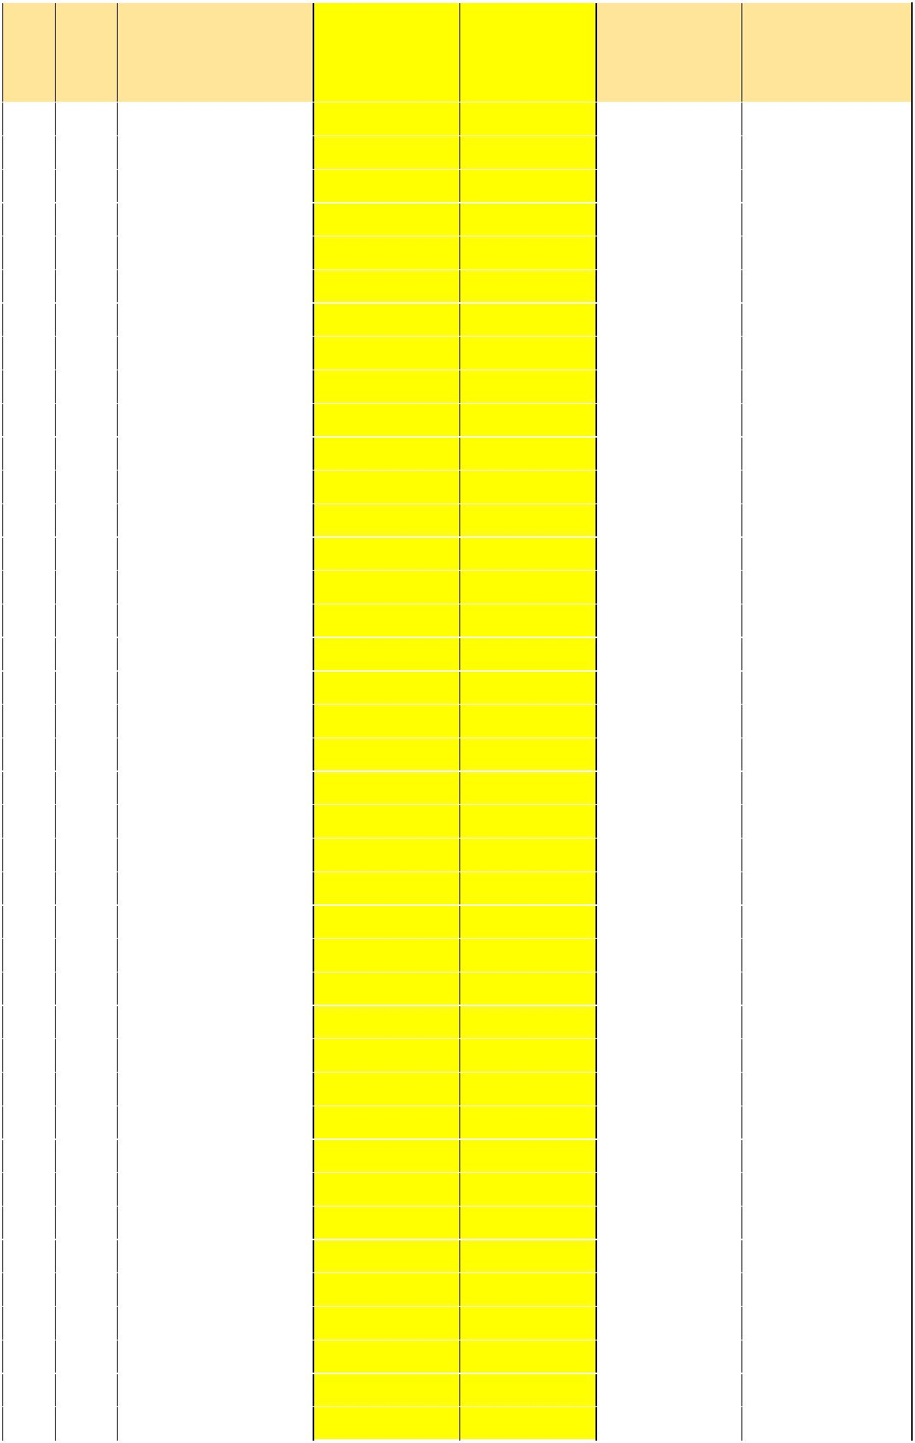
 |  |  |  |  | Health | Transitional |  | o/w | o/w
 |  |  |  |  | Health | Transitional |  | Transitional | Transitional
 |  | Vote |  | District | Development | Development |  | Transitional | Transitional
 |  | Vote |  | District | Development | Development |  | Development - | Development -
 |  |  |  |  | Grant (IGFT) | Grant |  | Development - | Development -
 |  |  |  |  | Grant (IGFT) | Grant |  | Health Ad Hoc | Sanitation
1 | 501 |  |  | Adjumani District | 554,208,123 | - |  |  | -
2 | 502 |  |  | Apac District | 530,156,535 | 404,690,327 | 300,000,000 |  | 104,690,327
3 | 503 |  |  | Arua District | 162,348,223 | 213,165,330 |  |  | 213,165,330
4 | 504 |  |  | Bugiri District | 72,154,766 | - |  |  | -
5 | 505 |  |  | Bundibugyo District | 1,074,414,832 | - |  |  | -
6 | 506 |  |  | Bushenyi District | 548,195,226 | 47,254,283 |  |  | 47,254,283
7 | 507 |  |  | Busia District | 1,068,401,935 | - |  |  | -
8 | 508 |  |  | Gulu District | 36,077,383 | - |  |  | -
9 | 509 |  |  | Hoima District | 48,103,177 | - |  |  | -
10 | 510 |  |  | Iganga District | 54,116,074 | - |  |  | -
11 | 511 |  |  | Jinja District | 78,167,663 | - |  |  | -
12 | 512 |  |  | Kabale District | 554,208,123 | - |  |  | -
13 | 513 |  |  | Kabarole District | 572,246,815 | - |  |  | -
14 | 514 |  |  | Kaberamaido District | 48,103,177 | 66,610,934 |  |  | 66,610,934
15 | 515 |  |  | Kalangala District | 48,103,177 | - |  |  | -
16 | 517 |  |  | Kamuli District | 578,259,712 | - |  |  | -
17 | 518 |  |  | Kamwenge District | 1,086,440,626 | 250,000,000 | 250,000,000 |  | -
18 | 519 |  |  | Kanungu District | 572,246,815 | - |  |  | -
19 | 520 |  |  | Kapchorwa District | 536,169,432 | - |  |  | -
20 | 521 |  |  | Kasese District | 1,134,543,803 | - |  |  | -
21 | 522 |  |  | Katakwi District | 536,169,432 | 80,687,345 |  |  | 80,687,345
22 | 523 |  |  | Kayunga District | 566,233,918 | - |  |  | -
23 | 524 |  |  | Kibaale District | 524,143,638 | - |  |  | -
24 | 525 |  |  | Kiboga District | 548,195,226 | 400,000,000 | 400,000,000 |  | -
25 | 526 |  |  | Kisoro District | 602,311,301 | - |  |  | -
26 | 527 |  |  | Kitgum District | 60,128,972 | - |  |  | -
27 | 528 |  |  | Kotido District | 30,064,486 | - |  |  | -
28 | 529 |  |  | Kumi District | 42,090,280 | 60,112,466 |  |  | 60,112,466
29 | 530 |  |  | Kyenjojo District | 1,080,427,729 | - |  |  | -
30 | 531 |  |  | Lira District | 48,103,177 | 124,998,150 |  |  | 124,998,150
31 | 532 |  |  | Luwero District | 614,337,095 | - |  |  | -
32 | 533 |  |  | Masaka District | 48,103,177 | - |  |  | -
33 | 534 |  |  | Masindi District | 54,116,074 | - |  |  | -
34 | 535 |  |  | Mayuge District | 1,062,389,037 | - |  |  | -
35 | 536 |  |  | Mbale District | 96,206,354 | - |  |  | -
36 | 537 |  |  | Mbarara District | 78,167,663 | 60,063,417 |  |  | 60,063,417
37 | 538 |  |  | Moroto District | 12,025,794 | - |  |  | -
38 | 539 |  |  | Moyo District | 78,167,663 | 80,761,786 |  |  | 80,761,786
39 | 540 |  |  | Mpigi District | 72,154,766 | 300,000,000 | 300,000,000 |  | -
40 | 541 |  |  | Mubende District | 1,068,401,935 | - |  |  | -

18
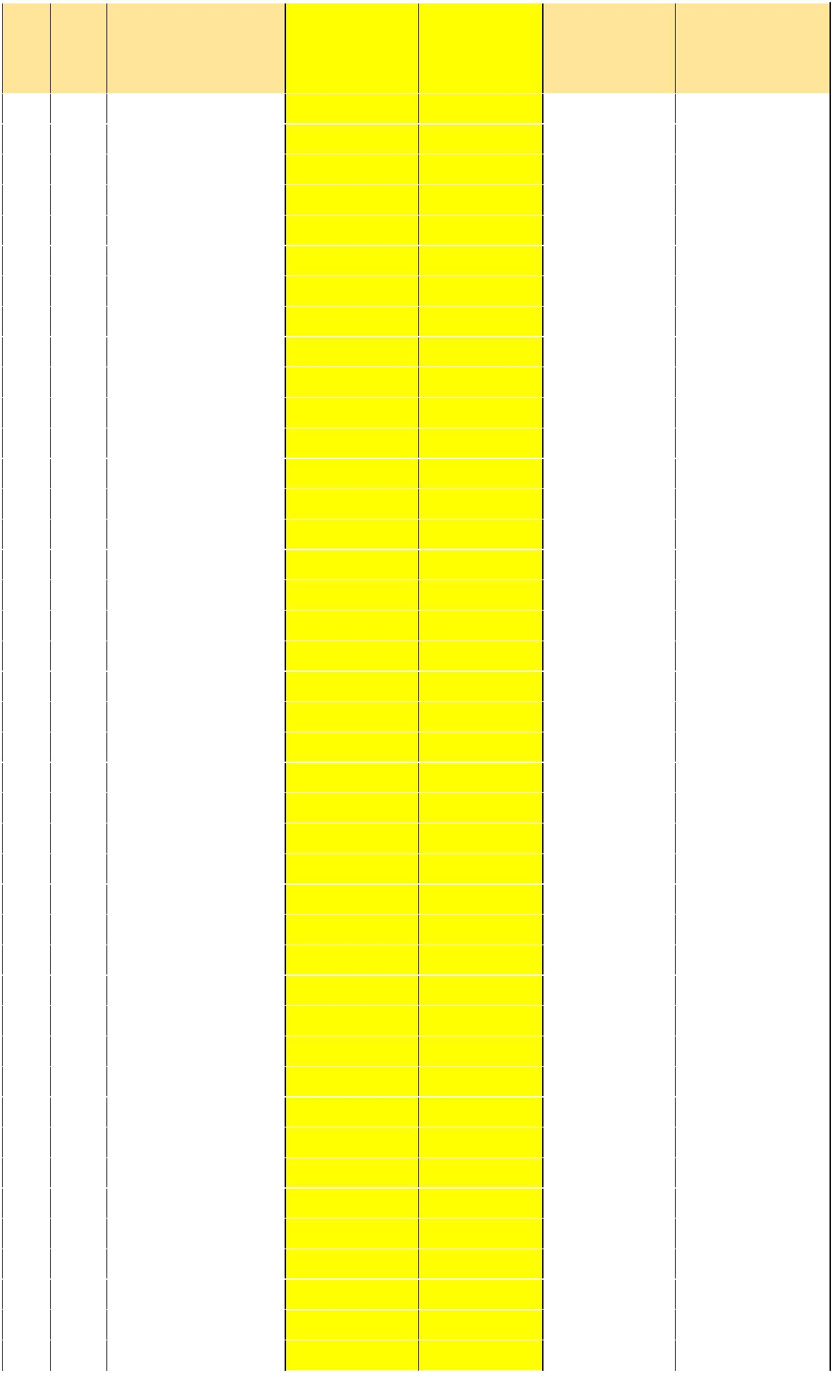 |  |  |  |  | Health | Transitional |  | o/w | o/w
 |  |  |  |  | Health | Transitional |  | Transitional | Transitional
 |  | Vote |  | District | Development | Development |  | Transitional | Transitional
 |  | Vote |  | District | Development | Development |  | Development - | Development -
 |  |  |  |  | Grant (IGFT) | Grant |  | Development - | Development -
 |  |  |  |  | Grant (IGFT) | Grant |  | Health Ad Hoc | Sanitation
41 | 542 |  |  | Mukono District | 78,167,663 | - |  |  | -
42 | 543 |  |  | Nakapiripiriti District | 24,051,589 | - |  |  | -
43 | 544 |  |  | Nakasongola District | 554,208,123 | - |  |  | -
44 | 545 |  |  | Nebbi District | 548,195,226 | 82,798,975 |  |  | 82,798,975
45 | 546 |  |  | Ntungamo District | 1,104,479,318 | - |  |  | -
46 | 547 |  |  | Pader District | 554,208,123 | - |  |  | -
47 | 548 |  |  | Pallisa District | 560,221,021 | 63,821,290 |  |  | 63,821,290
48 | 549 |  |  | Rakai District | 566,233,918 | - |  |  | -
49 | 550 |  |  | Rukungiri District | 572,246,815 | - |  |  | -
50 | 551 |  |  | Sembabule District | 536,169,432 | - |  |  | -
51 | 552 |  |  | Sironko District | 584,272,609 | - |  |  | -
52 | 553 |  |  | Soroti District | 48,103,177 | 70,230,089 |  |  | 70,230,089
53 | 554 |  |  | Tororo District | 614,337,095 | 250,000,000 | 250,000,000 |  | -
54 | 555 |  |  | Wakiso District | 620,349,992 | - |  |  | -
55 | 556 |  |  | Yumbe District | 1,068,401,935 | 91,560,270 |  |  | 91,560,270
56 | 557 |  |  | Butaleja District | 66,141,869 | 88,445,992 |  |  | 88,445,992
57 | 558 |  |  | Ibanda District | 530,156,535 | - |  |  | -
58 | 559 |  |  | Kaabong District | 36,077,383 | - |  |  | -
59 | 560 |  |  | Isingiro District | 626,362,889 | - |  |  | -
60 | 561 |  |  | Kaliro District | 1,050,363,243 | - |  |  | -
61 | 562 |  |  | Kiruhura District | 1,104,479,318 | - |  |  | -
62 | 563 |  |  | Koboko District | 42,090,280 | 80,761,786 |  |  | 80,761,786
63 | 564 |  |  | Amolatar District | 524,143,638 | 70,721,922 |  |  | 70,721,922
64 | 565 |  |  | Amuria District | 542,182,329 | 156,348,496 |  |  | 156,348,496
65 | 566 |  |  | Manafwa District | 530,156,535 | - |  |  | -
66 | 567 |  |  | Bukwo District | 524,143,638 | - |  |  | -
67 | 568 |  |  | Mityana District | 584,272,609 | - |  |  | -
68 | 569 |  |  | Nakaseke District | 548,195,226 | - |  |  | -
69 | 570 |  |  | Amuru District | 542,182,329 | - |  |  | -
70 | 571 |  |  | Budaka District | 560,221,021 | 93,043,880 |  |  | 93,043,880
71 | 572 |  |  | Oyam District | 1,050,363,243 | - |  |  | -
72 | 573 |  |  | Abim District | 24,051,589 | 300,000,000 | 300,000,000 |  | -
73 | 574 |  |  | Namutumba District | 542,182,329 | - |  |  | -
74 | 575 |  |  | Dokolo District | 1,050,363,243 | 67,769,385 |  |  | 67,769,385
75 | 576 |  |  | Buliisa District | 1,050,363,243 | - |  |  | -
76 | 577 |  |  | Maracha District | 554,208,123 | 278,212,487 | 200,000,000 |  | 78,212,487
77 | 578 |  |  | Bukedea District | 536,169,432 | 57,699,625 |  |  | 57,699,625
78 | 579 |  |  | Bududa District | 548,195,226 | - |  |  | -
79 | 580 |  |  | Lyantonde District | 530,156,535 | - |  |  | -
80 | 581 |  |  | Amudat District | 12,025,794 | - |  |  | -
81 | 582 |  |  | Buikwe District | 36,077,383 | - |  |  | -
82 | 583 |  |  | Buyende District | 30,064,486 | - |  |  | -

19
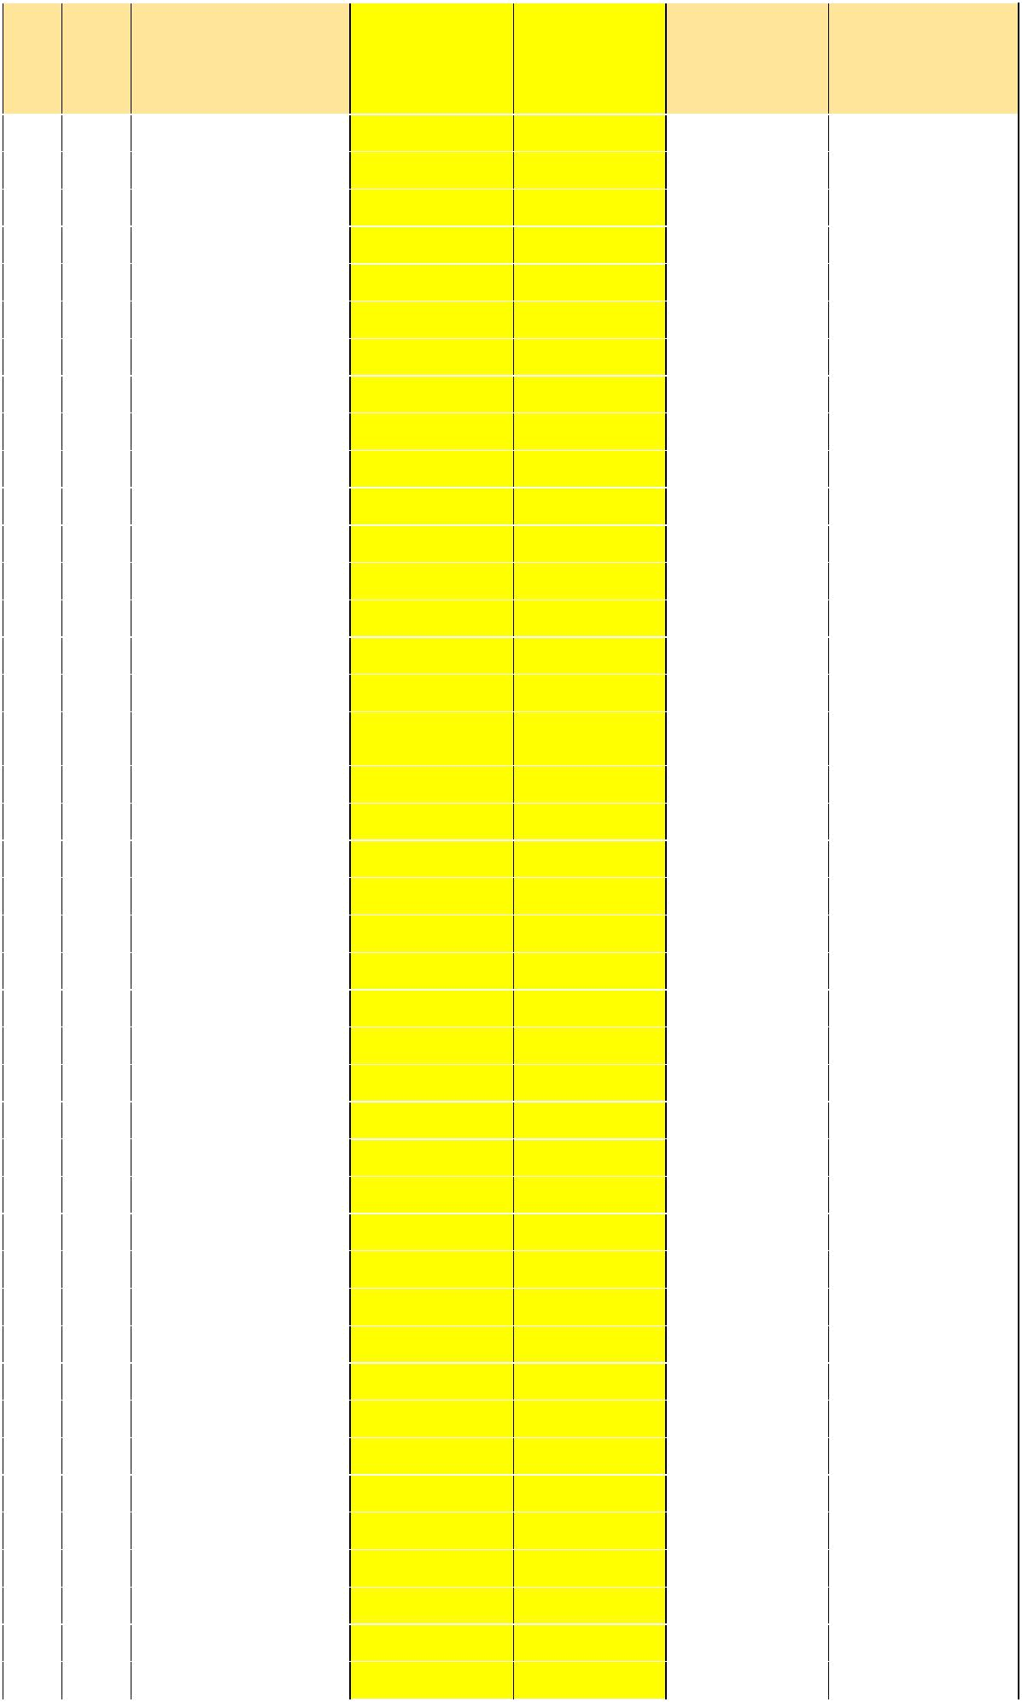 |  |  |  |  | Health | Transitional |  | o/w | o/w
 |  |  |  |  | Health | Transitional |  | Transitional | Transitional
 |  | Vote |  | District | Development | Development |  | Transitional | Transitional
 |  | Vote |  | District | Development | Development |  | Development - | Development -
 |  |  |  |  | Grant (IGFT) | Grant |  | Development - | Development -
 |  |  |  |  | Grant (IGFT) | Grant |  | Health Ad Hoc | Sanitation
83 | 584 |  |  | Kyegegwa District | 542,182,329 | - |  |  | -
84 | 585 |  |  | Lamwo District | 560,221,021 | - |  |  | -
85 | 586 |  |  | Otuke District | 536,169,432 | 79,250,478 |  |  | 79,250,478
86 | 587 |  |  | Zombo District | 536,169,432 | 102,817,676 |  |  | 102,817,676
87 | 588 |  |  | Alebtong District | 1,050,363,243 | 85,958,112 |  |  | 85,958,112
88 | 589 |  |  | Bulambuli District | 566,233,918 | 86,226,324 |  |  | 86,226,324
89 | 590 |  |  | Buvuma District | 24,051,589 | - |  |  | -
90 | 591 |  |  | Gomba District | 1,056,376,140 | - |  |  | -
91 | 592 |  |  | Kiryandongo District | 30,064,486 | - |  |  | -
92 | 593 |  |  | Luuka District | 542,182,329 | - |  |  | -
93 | 594 |  |  | Namayingo District | 530,156,535 | - |  |  | -
94 | 595 |  |  | Ntoroko District | 518,130,740 | - |  |  | -
95 | 596 |  |  | Serere District | 1,068,401,935 | 90,500,108 |  |  | 90,500,108
96 | 597 |  |  | Kyankwanzi District | 1,062,389,037 | - |  |  | -
97 | 598 |  |  | Kalungu District | 548,195,226 | - |  |  | -
98 | 599 |  |  | Lwengo District | 542,182,329 | - |  |  | -
99 | 600 |  |  | Bukomansimbi | 24,051,589 | - |  |  | -
 |  |  |  | District
100 | 601 |  |  | Mitooma District | 542,182,329 | - |  |  | -
101 | 602 |  |  | Rubirizi District | 1,044,350,346 | - |  |  | -
102 | 603 |  |  | Ngora District | 42,090,280 | 54,297,201 |  |  | 54,297,201
103 | 604 |  |  | Napak District | 30,064,486 | - |  |  | -
104 | 605 |  |  | Kibuku District | 548,195,226 | 65,651,294 |  |  | 65,651,294
105 | 606 |  |  | Nwoya District | 524,143,638 | - |  |  | -
106 | 607 |  |  | Kole District | 536,169,432 | 82,252,707 |  |  | 82,252,707
107 | 608 |  |  | Butambala District | 536,169,432 | - |  |  | -
108 | 609 |  |  | Sheema District | 1,050,363,243 | 60,063,417 |  |  | 60,063,417
109 | 610 |  |  | Buhweju District | 1,044,350,346 | - |  |  | -
110 | 611 |  |  | Agago District | 554,208,123 | - |  |  | -
111 | 612 |  |  | Kween District | 560,221,021 | - |  |  | -
112 | 613 |  |  | Kagadi District | 1,080,427,729 | - |  |  | -
113 | 614 |  |  | Kakumiro District | 1,068,401,935 | - |  |  | -
114 | 615 |  |  | Omoro District | 536,169,432 | - |  |  | -
115 | 616 |  |  | Rubanda District | 542,182,329 | - |  |  | -
116 | 617 |  |  | Namisindwa District | 48,103,177 | - |  |  | -
117 | 618 |  |  | Pakwach District | 42,090,280 | 65,564,364 |  |  | 65,564,364
118 | 619 |  |  | Butebo District | 530,156,535 | 33,778,209 |  |  | 33,778,209
119 | 620 |  |  | Rukiga District | 30,064,486 | - |  |  | -
120 | 621 |  |  | Kyotera District | 72,154,766 | 200,000,000 | 200,000,000 |  | -
121 | 622 |  |  | Bunyangabu District | 554,208,123 | - |  |  | -
122 | 623 |  |  | Nabilatuk District | 18,038,691 | - |  |  | -
123 | 624 |  |  | Bugweri District | 530,156,535 | - |  |  | -
124 | 625 |  |  | Kasanda District | 1,050,363,243 | - |  |  | -

20
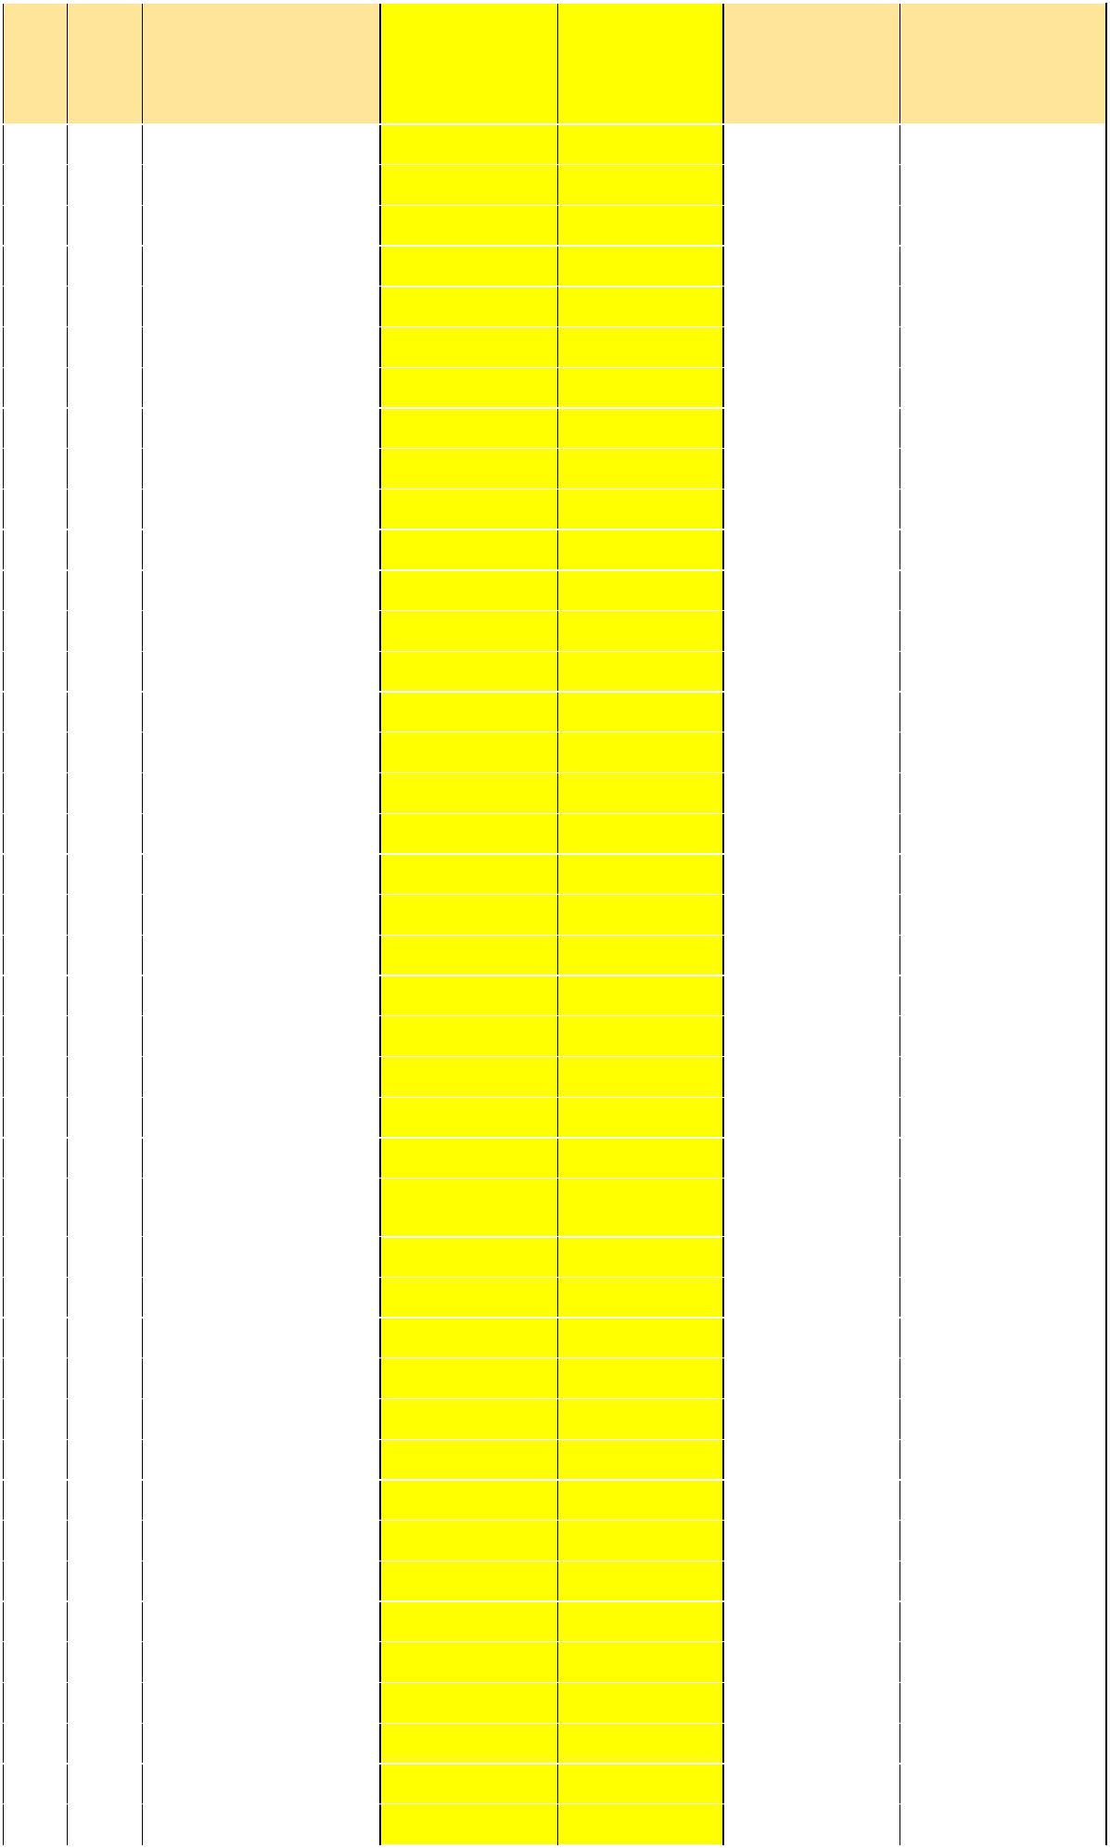 |  |  |  |  | Health | Transitional |  | o/w | o/w
 |  |  |  |  | Health | Transitional |  | Transitional | Transitional
 |  | Vote |  | District | Development | Development |  | Transitional | Transitional
 |  | Vote |  | District | Development | Development |  | Development - | Development -
 |  |  |  |  | Grant (IGFT) | Grant |  | Development - | Development -
 |  |  |  |  | Grant (IGFT) | Grant |  | Health Ad Hoc | Sanitation
125 | 626 |  |  | Kwania District | 42,090,280 | - |  |  | -
126 | 627 |  |  | Kapelebyong District | 18,038,691 | - |  |  | -
127 | 628 |  |  | Kikuube District | 102,219,252 | - |  |  | -
128 | 751 |  |  | Arua MC | 6,012,897 | - |  |  | -
129 | 752 |  |  | Entebbe MC | 6,012,897 | - |  |  | -
130 | 753 |  |  | Fort-Portal MC | 24,051,589 | - |  |  | -
131 | 754 |  |  | Gulu MC | 24,051,589 | - |  |  | -
132 | 755 |  |  | Jinja MC | 518,130,740 | - |  |  | -
133 | 757 |  |  | Kabale MC | 24,051,589 | - |  |  | -
134 | 758 |  |  | Lira MC | 12,025,794 | - |  |  | -
135 | 759 |  |  | Masaka MC | 500,092,049 | - |  |  | -
136 | 760 |  |  | Mbale MC | 24,051,589 | - |  |  | -
137 | 761 |  |  | Mbarara MC | 518,130,740 | - |  |  | -
138 | 762 |  |  | Moroto MC | - | - |  |  | -
139 | 763 |  |  | Soroti MC | 18,038,691 | - |  |  | -
140 | 764 |  |  | Tororo MC | 18,038,691 | - |  |  | -
141 | 770 |  |  | Kasese MC | 12,025,794 | - |  |  | -
142 | 771 |  |  | Hoima MC | 518,130,740 | - |  |  | -
143 | 772 |  |  | Mukono MC | 12,025,794 | - |  |  | -
144 | 773 |  |  | Iganga MC | 6,012,897 | - |  |  | -
145 | 774 |  |  | Masindi MC | 506,104,946 | - |  |  | -
146 | 775 |  |  | Ntungamo MC | 506,104,946 | - |  |  | -
147 | 776 |  |  | Busia MC | 6,012,897 | - |  |  | -
148 | 777 |  |  | Bushenyi- Ishaka MC | 6,012,897 | - |  |  | -
149 | 778 |  |  | Rukungiri MC | 512,117,843 | - |  |  | -
150 | 779 |  |  | Nansana MC | 42,090,280 | - |  |  | -
151 | 780 |  |  | Makindye-Ssabagabo | 30,064,486 | - |  |  | -
 |  |  |  | MC
152 | 781 |  |  | Kira MC | 12,025,794 | - |  |  | -
153 | 782 |  |  | Kisoro MC | 500,092,049 | - |  |  | -
154 | 783 |  |  | Mityana MC | 18,038,691 | - |  |  | -
155 | 784 |  |  | Kitgum MC | 500,092,049 | - |  |  | -
156 | 785 |  |  | Koboko MC | 506,104,946 | - |  |  | -
157 | 786 |  |  | Mubende MC | 500,092,049 | - |  |  | -
158 | 787 |  |  | Kumi MC | 6,012,897 | - |  |  | -
159 | 788 |  |  | Lugazi MC | 12,025,794 | - |  |  | -
160 | 789 |  |  | Kamuli MC | 500,092,049 | - |  |  | -
161 | 790 |  |  | Kapchorwa MC | 506,104,946 | - |  |  | -
162 | 791 |  |  | Ibanda MC | 18,038,691 | - |  |  | -
163 | 792 |  |  | Njeru MC | 18,038,691 | - |  |  | -
164 | 793 |  |  | Apac MC | - | - |  |  | -
165 | 794 |  |  | Nebbi MC | - | - |  |  | -
166 | 795 |  |  | Bugiri MC | 500,092,049 | - |  |  | -

21
 |  |  |  |  | Health | Transitional |  | o/w | o/w
 |  |  |  |  | Health | Transitional |  | Transitional | Transitional
 |  | Vote |  | District | Development | Development |  | Transitional | Transitional
 |  | Vote |  | District | Development | Development |  | Development - | Development -
 |  |  |  |  | Grant (IGFT) | Grant |  | Development - | Development -
 |  |  |  |  | Grant (IGFT) | Grant |  | Health Ad Hoc | Sanitation
167 | 796 |  |  | Sheema MC | 506,104,946 | - |  |  | -
168 | 797 |  |  | Kotido MC | 6,012,897 | - |  |  | -
 |  |  |  | Total | 69,360,894,450 | 4,846,118,123 | 2,200,000,000 |  | 2,646,118,123

22

6.2 Annex II: Break Down of Health Development Grant (IGFT) & Health Facilities for Upgrade in FY2018/19


 |  | HEALTH DEVELOPMENT GRANT
S/N Vote | Local Governments | (IGFT LOAN)
S/N Vote | Local Governments | Allocation of | Allocation for
No. |  | Health | upgrade of
 |  | Infrastructure | HCIIs to HC IIIs
 |  | Maintenance

Total IPFs FY | SUB COUNTIES AND HEALTH FACILITIES TO BE UPGRADED
Total IPFs FY | County | Sub County / TC | Health Facility | Approved
2018/19 |  |  | to be Upgraded | Budget

Allocations

1 | 501 |  | Adjumani District | 54,208,123 |  | 500,000,000 |  | 554,208,123 | East Moyo |  | Arinyapi |  | Arinyapi HC II | 500,000,000
2 | 502 |  | Apac District | 30,156,535 |  | 500,000,000 |  | 530,156,535 | Maruzi |  | Apac |  | Olelpek HC II | 500,000,000
3 | 503 |  | Arua District | 162,348,223 |  | - |  | 162,348,223 |  |  |  |  |  | -
4 | 504 |  | Bugiri District | 72,154,766 |  | - |  | 72,154,766 |  |  |  |  |  | -
5 | 505 |  | Bundibugyo District | 74,414,832 |  | 1,000,000,000 |  | 1,074,414,832 | Bughendera |  | Burondo |  | Burondo HC II | 500,000,000
 |  |  |  |  |  |  |  | - | Bughendera |  | Harugale |  | Bupomboli HC II | 500,000,000
6 | 506 |  | Bushenyi District | 48,195,226 |  | 500,000,000 |  | 548,195,226 | Igara |  | Kyamuhunga |  | Kibazi HC II | 500,000,000
7 | 507 |  | Busia District | 68,401,935 |  | 1,000,000,000 |  | 1,068,401,935 | Samia Bugwe North |  | Buyanga |  | Buwembe HC II | 500,000,000
 |  |  |  |  |  |  |  | - | Samia Bugwe South |  | Majanji |  | Majanji HC II | 500,000,000
8 | 508 |  | Gulu District | 36,077,383 |  | - |  | 36,077,383 |  |  |  |  |  | -
9 | 509 |  | Hoima District | 48,103,177 |  | - |  | 48,103,177
10 | 510 |  | Iganga District | 54,116,074 |  | - |  | 54,116,074 |  |  |  |  |  | -
11 | 511 |  | Jinja District | 78,167,663 |  | - |  | 78,167,663 |  |  |  |  |  | -
12 | 512 |  | Kabale District | 54,208,123 |  | 500,000,000 |  | 554,208,123 | Ndorwa |  | Kamuganguzi |  | Kasheregyenyi | 500,000,000
 |  |  |  |  |  |  |  |  |  |  |  |  | HC II
13 | 513 |  | Kabarole District | 72,246,815 |  | 500,000,000 |  | 572,246,815 | Burahya |  | Mugusu |  | Nyantabooma HC II | 500,000,000
14 | 514 |  | Kaberamaido District | 48,103,177 |  | - |  | 48,103,177 |  |  |  |  |  | -
15 | 515 |  | Kalangala District | 48,103,177 |  | - |  | 48,103,177 |  |  |  |  |  | -
16 | 517 |  | Kamuli District | 78,259,712 |  | 500,000,000 |  | 578,259,712 | Bugabula |  | Kagumba |  | Kagumba HC II | 500,000,000
17 | 518 |  | Kamwenge District | 86,440,626 |  | 1,000,000,000 |  | 1,086,440,626 | Kibaale |  | Kabambiro |  | Kabambiro HC II | 500,000,000
 |  |  |  |  |  |  |  | - | Kitagwenda |  | Kanara |  | Kanara HC II | 500,000,000
18 | 519 |  | Kanungu District | 72,246,815 |  | 500,000,000 |  | 572,246,815 | Kinkizi |  | Kihihi |  | Matanda HC II | 500,000,000
19 | 520 |  | Kapchorwa District | 36,169,432 |  | 500,000,000 |  | 536,169,432 | Tingey |  | Chema |  | Chemosong HC II | 500,000,000
20 | 521 |  | Kasese District | 134,543,803 |  | 1,000,000,000 |  | 1,134,543,803 | Bukonzo West |  | Bwera |  | Nyakimasa HC II | 500,000,000
 |  |  |  |  |  |  |  | - | Bukonzo West |  | Isango |  | Kyempara HC II | 500,000,000
21 | 522 |  | Katakwi District | 36,169,432 |  | 500,000,000 |  | 536,169,432 | Usuk |  | Katakwi |  | Aliakamer HC II | 500,000,000
22 | 523 |  | Kayunga District | 66,233,918 |  | 500,000,000 |  | 566,233,918 | Ntenjeru South |  | Nazigo |  | Bukamba HC II | 500,000,000
 |  |  |  |  |  |  |  | 23

 |  | HEALTH DEVELOPMENT GRANT
 |  | (IGFT LOAN)
S/N Vote | Local Governments
S/N Vote | Local Governments | Allocation of | Allocation for
No. |  | Health | upgrade of
 |  | Infrastructure | HCIIs to HC IIIs
 |  | Maintenance

 | SUB COUNTIES AND HEALTH FACILITIES TO BE UPGRADED
Total IPFs FY
Total IPFs FY | County | Sub County / TC | Health Facility | Approved
2018/19 |  |  | to be Upgraded | Budget

Allocations

23 | 524 |  | Kibaale District | 24,143,638 |  | 500,000,000 |  | 524,143,638 | Buyanja |  | Matale |  | Matale HC II | 500,000,000
24 | 525 |  | Kiboga District | 48,195,226 |  | 500,000,000 |  | 548,195,226 | Kiboga East |  | Lwamata |  | Bulaga HC II | 500,000,000
25 | 526 |  | Kisoro District | 102,311,301 |  | 500,000,000 |  | 602,311,301 | Bufumbira East |  | Murora |  | Chibumba HC II | 500,000,000
26 | 527 |  | Kitgum District | 60,128,972 |  | - |  | 60,128,972 |  |  |  |  |  | -
27 | 528 |  | Kotido District | 30,064,486 |  | - |  | 30,064,486 |  |  |  |  |  | -
28 | 529 |  | Kumi District | 42,090,280 |  | - |  | 42,090,280 |  |  |  |  |  | -
29 | 530 |  | Kyenjojo District | 80,427,729 |  | 1,000,000,000 |  | 1,080,427,729 | Mwenge Central |  | Katooke |  | Myeri HC II | 500,000,000
 |  |  |  |  |  |  |  | - | Mwenge South |  | Kihuura |  | Kyakaramata HC | 500,000,000
 |  |  |  |  |  |  |  |  |  |  |  |  | II
30 | 531 |  | Lira District | 48,103,177 |  | - |  | 48,103,177 |  |  |  |  |  | -
31 | 532 |  | Luwero District | 114,337,095 |  | 500,000,000 |  | 614,337,095 | Katikamu |  | Luwero |  | Katuugo HC II | 500,000,000
32 | 533 |  | Masaka District | 48,103,177 |  | - |  | 48,103,177 |  |  |  |  |  | -
33 | 534 |  | Masindi District | 54,116,074 |  | - |  | 54,116,074 |  |  |  |  |  | -
34 | 535 |  | Mayuge District | 62,389,037 |  | 1,000,000,000 |  | 1,062,389,037 | Bunya |  | Jagusi |  | Jagusi HC II | 500,000,000
 |  |  |  |  |  |  |  | - | Bunya |  | Busakira |  | Busaala HC II | 500,000,000
35 | 536 |  | Mbale District | 96,206,354 |  | - |  | 96,206,354 |  |  |  |  |  | -
36 | 537 |  | Mbarara District | 78,167,663 |  | - |  | 78,167,663 |  |  |  |  |  | -
37 | 538 |  | Moroto District | 12,025,794 |  | - |  | 12,025,794 |  |  |  |  |  | -
38 | 539 |  | Moyo District | 78,167,663 |  | - |  | 78,167,663 |  |  |  |  |  | -
39 | 540 |  | Mpigi District | 72,154,766 |  | - |  | 72,154,766 |  |  |  |  |  | -
40 | 541 |  | Mubende District | 68,401,935 |  | 1,000,000,000 |  | 1,068,401,935 | Kasambya |  | Kigando |  | Butawata HC II | 500,000,000
 |  |  |  |  |  |  |  | - | Buweekula |  | Butoloogo |  | Butoloogo HC II | 500,000,000
41 | 542 |  | Mukono District | 78,167,663 |  | - |  | 78,167,663 |  |  |  |  |  | -
42 | 543 |  | Nakapiripiriti District | 24,051,589 |  | - |  | 24,051,589 |  |  |  |  |  | -
43 | 544 |  | Nakasongola District | 54,208,123 |  | 500,000,000 |  | 554,208,123 | Nakasongola |  | Kakooge |  | Kiralamba HC II | 500,000,000
44 | 545 |  | Nebbi District | 48,195,226 |  | 500,000,000 |  | 548,195,226 | Padyere |  | Ndheu |  | Oweko HC II | 500,000,000
45 | 546 |  | Ntungamo District | 104,479,318 |  | 1,000,000,000 |  | 1,104,479,318 | Ruhama |  | Rukoni East |  | Kyamwasha HC II | 500,000,000
 |  |  |  |  |  |  |  | 24

 |  | HEALTH DEVELOPMENT GRANT
 |  | (IGFT LOAN)
S/N Vote | Local Governments
S/N Vote | Local Governments | Allocation of | Allocation for
No. |  | Health | upgrade of
 |  | Infrastructure | HCIIs to HC IIIs
 |  | Maintenance

 | SUB COUNTIES AND HEALTH FACILITIES TO BE UPGRADED
Total IPFs FY
Total IPFs FY | County | Sub County / TC | Health Facility | Approved
2018/19 |  |  | to be Upgraded | Budget

Allocations

 |  |  |  |  |  |  |  | - | Kajara |  | Nyabihoko |  | Karuruma HC II | 500,000,000
46 | 547 |  | Pader District | 54,208,123 |  | 500,000,000 |  | 554,208,123 | Aruu North |  | Atanga |  | Lapul Ocwida HC | 500,000,000
 |  |  |  |  |  |  |  |  |  |  |  |  | II
47 | 548 |  | Pallisa District | 60,221,021 |  | 500,000,000 |  | 560,221,021 | Pallisa |  | Olok |  | Olok HC II | 500,000,000
48 | 549 |  | Rakai District | 66,233,918 |  | 500,000,000 |  | 566,233,918 | Kooki |  | Kiziba |  | Rakai Kiziba HC II | 500,000,000
49 | 550 |  | Rukungiri District | 72,246,815 |  | 500,000,000 |  | 572,246,815 | Rubabo |  | Kebisoni |  | Karuhembe HC II | 500,000,000
50 | 551 |  | Sembabule District | 36,169,432 |  | 500,000,000 |  | 536,169,432 | Mawogola |  | Mijwala |  | Busheka | 500,000,000
 |  |  |  |  |  |  |  |  |  |  |  |  | (Sembabule) HC
 |  |  |  |  |  |  |  |  |  |  |  |  | II
51 | 552 |  | Sironko District | 84,272,609 |  | 500,000,000 |  | 584,272,609 | Budadri West |  | Bukhulo |  | Bundege HC II | 500,000,000
52 | 553 |  | Soroti District | 48,103,177 |  | - |  | 48,103,177 |  |  |  |  |  | -
53 | 554 |  | Tororo District | 114,337,095 |  | 500,000,000 |  | 614,337,095 | West Budama |  | Sop Sop |  | Sop Sop HC II | 500,000,000
54 | 555 |  | Wakiso District | 120,349,992 |  | 500,000,000 |  | 620,349,992 | Busiro North |  | Namayumba |  | Nakitokolo | 500,000,000
 |  |  |  |  |  |  |  |  |  |  |  |  | Namayumba HC
 |  |  |  |  |  |  |  |  |  |  |  |  | II
55 | 556 |  | Yumbe District | 68,401,935 |  | 1,000,000,000 |  | 1,068,401,935 | Aringa South |  | Midigo |  | Mocha HC II | 500,000,000
 |  |  |  |  |  |  |  | - | Aringa North |  | Kerwa |  | Kerwa HC II | 500,000,000
56 | 557 |  | Butaleja District | 66,141,869 |  | - |  | 66,141,869 |  |  |  |  |  | -
57 | 558 |  | Ibanda District | 30,156,535 |  | 500,000,000 |  | 530,156,535 | Ibanda |  | Ishongororo |  | Kashozi (Ibanda) | 500,000,000
 |  |  |  |  |  |  |  |  |  |  |  |  | HC II
58 | 559 |  | Kaabong District | 36,077,383 |  | - |  | 36,077,383 |  |  |  |  |  | -
59 | 560 |  | Isingiro District | 126,362,889 |  | 500,000,000 |  | 626,362,889 | Bukanga |  | Endinzi |  | Busheka | 500,000,000
 |  |  |  |  |  |  |  |  |  |  |  |  | (Isingiro) HC II
60 | 561 |  | Kaliro District | 50,363,243 |  | 1,000,000,000 |  | 1,050,363,243 | Bulamogi |  | Budomero |  | Budomero HC II | 500,000,000
 |  |  |  |  |  |  |  | - | Bulamogi North |  | Bukamba |  | Nawampiti HC II | 500,000,000
 |  |  |  |  |  |  |  |  | West
61 | 562 |  | Kiruhura District | 104,479,318 |  | 1,000,000,000 |  | 1,104,479,318 | Nyabushozi |  | Kikatsi |  | Rwesande HC II | 500,000,000
 |  |  |  |  |  |  |  | - | Nyabushozi |  | Kitura |  | Kitura HC II | 500,000,000
62 | 563 |  | Koboko District | 42,090,280 |  | - |  | 42,090,280 |  |  |  |  |  | -
 |  |  |  |  |  |  |  | 25

 |  | HEALTH DEVELOPMENT GRANT
 |  | (IGFT LOAN)
S/N Vote | Local Governments
S/N Vote | Local Governments | Allocation of | Allocation for
No. |  | Health | upgrade of
 |  | Infrastructure | HCIIs to HC IIIs
 |  | Maintenance

 | SUB COUNTIES AND HEALTH FACILITIES TO BE UPGRADED
Total IPFs FY
Total IPFs FY | County | Sub County / TC | Health Facility | Approved
2018/19 |  |  | to be Upgraded | Budget

Allocations

63 | 564 |  | Amolatar District | 24,143,638 |  | 500,000,000 |  | 524,143,638 | Kioga |  | Muntu |  | Nakatiti HC II | 500,000,000
64 | 565 |  | Amuria District | 42,182,329 |  | 500,000,000 |  | 542,182,329 | Amuria |  | Akeriau |  | Akeriau HC II | 500,000,000
65 | 566 |  | Manafwa District | 30,156,535 |  | 500,000,000 |  | 530,156,535 | Bubulo West |  | Kaato |  | Bukimanayi HC II | 500,000,000
66 | 567 |  | Bukwo District | 24,143,638 |  | 500,000,000 |  | 524,143,638 | Kongasis |  | Kabei |  | Mutushet HC II | 500,000,000
67 | 568 |  | Mityana District | 84,272,609 |  | 500,000,000 |  | 584,272,609 | Mityana South |  | Namungo |  | Namungo HC II | 500,000,000
68 | 569 |  | Nakaseke District | 48,195,226 |  | 500,000,000 |  | 548,195,226 | Nakaseke North |  | Butalangu TC |  | Butalangu HC II | 500,000,000
69 | 570 |  | Amuru District | 42,182,329 |  | 500,000,000 |  | 542,182,329 | Kilak South |  | Amuru TC |  | Otwee HC III | 500,000,000
70 | 571 |  | Budaka District | 60,221,021 |  | 500,000,000 |  | 560,221,021 | Budaka |  | Kakule |  | Namusita | 500,000,000
 |  |  |  |  |  |  |  |  |  |  |  |  | (Budaka) HC II
71 | 572 |  | Oyam District | 50,363,243 |  | 1,000,000,000 |  | 1,050,363,243 | Oyam South |  | Aber |  | Atura HC II | 500,000,000
 |  |  |  |  |  |  |  | - | Oyam North |  | Aboke |  | Ariba HC II | 500,000,000
72 | 573 |  | Abim District | 24,051,589 |  | - |  | 24,051,589 |  |  |  |  |  | -
73 | 574 |  | Namutumba District | 42,182,329 |  | 500,000,000 |  | 542,182,329 | Busiki |  | Mazuba |  | Namutumba | 500,000,000
 |  |  |  |  |  |  |  |  |  |  |  |  | Kagulu HC II
74 | 575 |  | Dokolo District | 50,363,243 |  | 1,000,000,000 |  | 1,050,363,243 | Dokolo |  | Adeknino |  | Awelo HC II | 500,000,000
 |  |  |  |  |  |  |  | - | Dokolo |  | Adok |  | Adok HC II | 500,000,000
75 | 576 |  | Buliisa District | 50,363,243 |  | 1,000,000,000 |  | 1,050,363,243 | Buliisa |  | Ngwendo |  | Avogera HC II | 500,000,000
 |  |  |  |  |  |  |  | - | Buliisa |  | Butiaba |  | Butiaba HC II | 500,000,000
76 | 577 |  | Maracha District | 54,208,123 |  | 500,000,000 |  | 554,208,123 | Maracha East |  | Paranga |  | Ajikoro HC II | 500,000,000
77 | 578 |  | Bukedea District | 36,169,432 |  | 500,000,000 |  | 536,169,432 | Bukedea |  | Bukedea |  | Akuoro HC II | 500,000,000
78 | 579 |  | Bududa District | 48,195,226 |  | 500,000,000 |  | 548,195,226 | Manjia |  | Bushika |  | Bubungi HC II | 500,000,000
79 | 580 |  | Lyantonde District | 30,156,535 |  | 500,000,000 |  | 530,156,535 | Kabula |  | Lyakajura |  | Lyakajura HC II | 500,000,000
80 | 581 |  | Amudat District | 12,025,794 |  | - |  | 12,025,794 |  |  |  |  |  | -
81 | 582 |  | Buikwe District | 36,077,383 |  | - |  | 36,077,383 |  |  |  |  |  | -
82 | 583 |  | Buyende District | 30,064,486 |  | - |  | 30,064,486 |  |  |  |  |  | -
83 | 584 |  | Kyegegwa District | 42,182,329 |  | 500,000,000 |  | 542,182,329 | Kyaka |  | Ruyonza |  | Karwenyi HC II | 500,000,000
84 | 585 |  | Lamwo District | 60,221,021 |  | 500,000,000 |  | 560,221,021 | Lamwo |  | Padibe East |  | Katum HC II | 500,000,000
85 | 586 |  | Otuke District | 36,169,432 |  | 500,000,000 |  | 536,169,432 | Otuke |  | Ogwette |  | Ogwete HC II | 500,000,000
 |  |  |  |  |  |  |  | 26

 |  | HEALTH DEVELOPMENT GRANT
 |  | (IGFT LOAN)
S/N Vote | Local Governments
S/N Vote | Local Governments | Allocation of | Allocation for
No. |  | Health | upgrade of
 |  | Infrastructure | HCIIs to HC IIIs
 |  | Maintenance

 | SUB COUNTIES AND HEALTH FACILITIES TO BE UPGRADED
Total IPFs FY
Total IPFs FY | County | Sub County / TC | Health Facility | Approved
2018/19 |  |  | to be Upgraded | Budget

Allocations

86 | 587 |  | Zombo District | 36,169,432 |  | 500,000,000 |  | 536,169,432 | Okoro |  | Atyak |  | Ther-uru HC II | 500,000,000
87 | 588 |  | Alebtong District | 50,363,243 |  | 1,000,000,000 |  | 1,050,363,243 | Ajuri |  | Awei |  | Awei HC II | 500,000,000
 |  |  |  |  |  |  |  | - | Ajuri |  | Angetta |  | Angetta HC II | 500,000,000
88 | 589 |  | Bulambuli District | 66,233,918 |  | 500,000,000 |  | 566,233,918 | Bulambuli |  | Nabongo |  | Bunangaka HC II | 500,000,000
89 | 590 |  | Buvuma District | 24,051,589 |  | - |  | 24,051,589 |  |  |  |  |  | -
90 | 591 |  | Gomba District | 56,376,140 |  | 1,000,000,000 |  | 1,056,376,140 | Gomba |  | Kyegonza |  | Mamba HC II | 500,000,000
 |  |  |  |  |  |  |  | - | Gomba |  | Ngomanene |  | Ngomanene HC | 500,000,000
 |  |  |  |  |  |  |  |  |  |  |  |  | II
91 | 592 |  | Kiryandongo District | 30,064,486 |  | - |  | 30,064,486 |  |  |  |  |  | -
92 | 593 |  | Luuka District | 42,182,329 |  | 500,000,000 |  | 542,182,329 | Luuka |  | Bulongo |  | Bukendi HC II | 500,000,000
93 | 594 |  | Namayingo District | 30,156,535 |  | 500,000,000 |  | 530,156,535 | Bukoli Islands |  | Lolwe |  | Lolwe HC II | 500,000,000
94 | 595 |  | Ntoroko District | 18,130,740 |  | 500,000,000 |  | 518,130,740 | Ntoroko |  | Bweramule |  | Bweramule HC II | 500,000,000
95 | 596 |  | Serere District | 68,401,935 |  | 1,000,000,000 |  | 1,068,401,935 | Kasilo |  | Kadungulu |  | Kagwara HC II | 500,000,000
 |  |  |  |  |  |  |  | - | Kasilo |  | Labori |  | Aarapoo HC II | 500,000,000
96 | 597 |  | Kyankwanzi District | 62,389,037 |  | 1,000,000,000 |  | 1,062,389,037 | Butemba |  | Bananywa |  | Bananywa HC II | 500,000,000
 |  |  |  |  |  |  |  | - | Ntwetwe |  | Wattuba |  | Kikolimbo HC II | 500,000,000
97 | 598 |  | Kalungu District | 48,195,226 |  | 500,000,000 |  | 548,195,226 | Kalungu |  | Kyamuliibwa |  | Kabaale HC II | 500,000,000
98 | 599 |  | Lwengo District | 42,182,329 |  | 500,000,000 |  | 542,182,329 | Bukoto West |  | Kyazanga |  | Kakoma HC II | 500,000,000
99 | 600 |  | Bukomansimbi District | 24,051,589 |  | - |  | 24,051,589 |  |  |  |  |  | -
100 | 601 |  | Mitooma District | 42,182,329 |  | 500,000,000 |  | 542,182,329 | Ruhinda |  | Kashenshero |  | Bukuba HC II | 500,000,000
101 | 602 |  | Rubirizi District | 44,350,346 |  | 1,000,000,000 |  | 1,044,350,346 | Katerera |  | Katanda |  | Munyonyi HC II | 500,000,000
 |  |  |  |  |  |  |  | - | Bunyaruguru |  | Ryeru |  | Mushumba HC II | 500,000,000
102 | 603 |  | Ngora District | 42,090,280 |  | - |  | 42,090,280 |  |  |  |  |  | -
103 | 604 |  | Napak District | 30,064,486 |  | - |  | 30,064,486 |  |  |  |  |  | -
104 | 605 |  | Kibuku District | 48,195,226 |  | 500,000,000 |  | 548,195,226 | Kibuku |  | Kibuku |  | Nalubembe HC II | 500,000,000
105 | 606 |  | Nwoya District | 24,143,638 |  | 500,000,000 |  | 524,143,638 | Nwoya |  | Koch Lii |  | Koch Lii HC II | 500,000,000
106 | 607 |  | Kole District | 36,169,432 |  | 500,000,000 |  | 536,169,432 | Kole South |  | Ayer |  | Ayer HC II | 500,000,000
107 | 608 |  | Butambala District | 36,169,432 |  | 500,000,000 |  | 536,169,432 | Butambala |  | Kibibi |  | Butaaka HC II | 500,000,000
 |  |  |  |  |  |  |  | 27

 |  | HEALTH DEVELOPMENT GRANT
 |  | (IGFT LOAN)
S/N Vote | Local Governments
S/N Vote | Local Governments | Allocation of | Allocation for
No. |  | Health | upgrade of
 |  | Infrastructure | HCIIs to HC IIIs
 |  | Maintenance

 | SUB COUNTIES AND HEALTH FACILITIES TO BE UPGRADED
Total IPFs FY
Total IPFs FY | County | Sub County / TC | Health Facility | Approved
2018/19 |  |  | to be Upgraded | Budget

Allocations

108 | 609 |  | Sheema District | 50,363,243 |  | 1,000,000,000 |  | 1,050,363,243 | Sheema North |  | Masheruka TC |  | Mabaare HC II | 500,000,000
 |  |  |  |  |  |  |  | - | Sheema South |  | Kasaana |  | Kyeihara HC II | 500,000,000
109 | 610 |  | Buhweju District | 44,350,346 |  | 1,000,000,000 |  | 1,044,350,346 | Buhweju |  | Buhunga |  | Mushasha HC II | 500,000,000
 |  |  |  |  |  |  |  | - | Buhweju |  | Engaju |  | Engaju HC II | 500,000,000
110 | 611 |  | Agago District | 54,208,123 |  | 500,000,000 |  | 554,208,123 | Agago South |  | Lukole |  | Lapirin HC II | 500,000,000
111 | 612 |  | Kween District | 60,221,021 |  | 500,000,000 |  | 560,221,021 | Kween |  | Kitawoi |  | Terenpoy HC II | 500,000,000
112 | 613 |  | Kagadi District | 80,427,729 |  | 1,000,000,000 |  | 1,080,427,729 | Buyaga West |  | Muhorro TC |  | Muhorro HC II | 500,000,000
 |  |  |  |  |  |  |  | - | Buyaga East |  | Paachwa |  | Kyabasara HC II | 500,000,000
113 | 614 |  | Kakumiro District | 68,401,935 |  | 1,000,000,000 |  | 1,068,401,935 | Bugangaizi West |  | Birembo |  | Birembo HC II | 500,000,000
 |  |  |  |  |  |  |  | - | Bugangaizi West |  | Kijangi |  | Kigando HC II | 500,000,000
114 | 615 |  | Omoro District | 36,169,432 |  | 500,000,000 |  | 536,169,432 | Omoro |  | Lakwaya |  | Loyoajonga HC II | 500,000,000
115 | 616 |  | Rubanda District | 42,182,329 |  | 500,000,000 |  | 542,182,329 | Rubanda |  | Hamurwa |  | Mpungu HC II | 500,000,000
116 | 617 |  | Namisindwa District | 48,103,177 |  | - |  | 48,103,177 |  |  |  |  |  | -
117 | 618 |  | Pakwach District | 42,090,280 |  | - |  | 42,090,280 |  |  |  |  |  | -
118 | 619 |  | Butebo District | 30,156,535 |  | 500,000,000 |  | 530,156,535 | Butebo |  | Butebo |  | Kanyumu HC II | 500,000,000
119 | 620 |  | Rukiga District | 30,064,486 |  | - |  | 30,064,486 |  |  |  |  |  | -
120 | 621 |  | Kyotera District | 72,154,766 |  | - |  | 72,154,766 |  |  |  |  |  | -
121 | 622 |  | Bunyangabu District | 54,208,123 |  | 500,000,000 |  | 554,208,123 | Bunyangabu |  | Buheesi |  | Kabahango HC II | 500,000,000
122 | 623 |  | Nabilatuk District | 18,038,691 |  | - |  | 18,038,691 |  |  |  |  |  | -
123 | 624 |  | Bugweri | 30,156,535 |  | 500,000,000 |  | 530,156,535 | Bugweri |  | Namalemba |  | Nawangisa HC II | 500,000,000
124 | 625 |  | Kasanda District | 50,363,243 |  | 1,000,000,000 |  | 1,050,363,243 | Bukuya |  | Kitumbi |  | Buseregenyu HC II | 500,000,000
 |  |  |  |  |  |  |  | - | Kassanda |  | Kalwana |  | Kikandwa HC II | 500,000,000
125 | 626 |  | Kwania District | 42,090,280 |  | - |  | 42,090,280 |  |  |  |  |  | -
126 | 627 |  | Kapelebyong District | 18,038,691 |  | - |  | 18,038,691 |  |  |  |  |  | -
127 | 628 |  | Kikuube District | 102,219,252 |  | - |  | 102,219,252 |  |  |  |  |  | -
128 | 751 |  | Arua MC | 6,012,897 |  | - |  | 6,012,897 |  |  |  |  |  | -
129 | 752 |  | Entebbe MC | 6,012,897 |  | - |  | 6,012,897 |  |  |  |  |  | -
130 | 753 |  | Fort-Portal MC | 24,051,589 |  | - |  | 24,051,589 |  |  |  |  |  | -
 |  |  |  |  |  |  |  | 28

 |  | HEALTH DEVELOPMENT GRANT
 |  | (IGFT LOAN)
S/N Vote | Local Governments
S/N Vote | Local Governments | Allocation of | Allocation for
No. |  | Health | upgrade of
 |  | Infrastructure | HCIIs to HC IIIs
 |  | Maintenance

 | SUB COUNTIES AND HEALTH FACILITIES TO BE UPGRADED
Total IPFs FY
Total IPFs FY | County | Sub County / TC | Health Facility | Approved
2018/19 |  |  | to be Upgraded | Budget

Allocations

131 | 754 |  | Gulu MC | 24,051,589 |  | - |  | 24,051,589 |  |  |  |  |  | -
132 | 755 |  | Jinja MC | 18,130,740 |  | 500,000,000 |  | 518,130,740 | Jinja MC West |  | Kimaka/ |  | Kimaka HC II | 500,000,000
 |  |  |  |  |  |  |  |  |  |  | Mpumudde/
 |  |  |  |  |  |  |  |  |  |  | Nalufenya
 |  |  |  |  |  |  |  |  |  |  | Division
133 | 757 |  | Kabale MC | 24,051,589 |  | - |  | 24,051,589 |  |  |  |  |  | -
134 | 758 |  | Lira MC | 12,025,794 |  | - |  | 12,025,794 |  |  |  |  |  | -
135 | 759 |  | Masaka MC | 92,049 |  | 500,000,000 |  | 500,092,049 | Masaka MC |  | Nyendo- |  | Nyendo HC II | 500,000,000
 |  |  |  |  |  |  |  |  |  |  | Senyange
 |  |  |  |  |  |  |  |  |  |  | Division
136 | 760 |  | Mbale MC | 24,051,589 |  | - |  | 24,051,589 |  |  |  |  |  | -
137 | 761 |  | Mbarara MC | 18,130,740 |  | 500,000,000 |  | 518,130,740 | Mbarara MC |  | Kakiika Division |  | Kyarwabuganda | 500,000,000
 |  |  |  |  |  |  |  |  |  |  |  |  | HC II
138 | 762 |  | Moroto MC | - |  | - |  | - |  |  |  |  |  | -
139 | 763 |  | Soroti MC | 18,038,691 |  | - |  | 18,038,691 |  |  |  |  |  | -
140 | 764 |  | Tororo MC | 18,038,691 |  | - |  | 18,038,691 |  |  |  |  |  | -
141 | 770 |  | Kasese MC | 12,025,794 |  | - |  | 12,025,794 |  |  |  |  |  | -
142 | 771 |  | Hoima MC | 18,130,740 |  | 500,000,000 |  | 518,130,740 | Hoima MC |  | Busiisi Division |  | Kihuukya HC II | 500,000,000
143 | 772 |  | Mukono MC | 12,025,794 |  | - |  | 12,025,794 |  |  |  |  |  | -
144 | 773 |  | Iganga MC | 6,012,897 |  | - |  | 6,012,897 |  |  |  |  |  | -
145 | 774 |  | Masindi MC | 6,104,946 |  | 500,000,000 |  | 506,104,946 | Masindi MC |  | Nyangahya |  | Katasenywa HC II | 500,000,000
 |  |  |  |  |  |  |  |  |  |  | Division
146 | 775 |  | Ntungamo MC | 6,104,946 |  | 500,000,000 |  | 506,104,946 | Ntungamo MC |  | Ntungamo |  | Ruhoko HC II | 500,000,000
 |  |  |  |  |  |  |  |  |  |  | Eastern Division
147 | 776 |  | Busia MC | 6,012,897 |  | - |  | 6,012,897 |  |  |  |  |  | -
148 | 777 |  | Bushenyi- Ishaka MC | 6,012,897 |  | - |  | 6,012,897 |  |  |  |  |  | -
149 | 778 |  | Rukungiri MC | 12,117,843 |  | 500,000,000 |  | 512,117,843 | Rukungiri MC |  | Rukungiri |  | Kitimba HC II | 500,000,000
 |  |  |  |  |  |  |  |  |  |  | Western Division
150 | 779 |  | Nansana MC | 42,090,280 |  | - |  | 42,090,280 |  |  |  |  |  | -
 |  |  |  |  |  |  |  | 29

 |  | HEALTH DEVELOPMENT GRANT
 |  | (IGFT LOAN)
S/N Vote | Local Governments
S/N Vote | Local Governments | Allocation of | Allocation for
No. |  | Health | upgrade of
 |  | Infrastructure | HCIIs to HC IIIs
 |  | Maintenance

 | SUB COUNTIES AND HEALTH FACILITIES TO BE UPGRADED
Total IPFs FY
Total IPFs FY | County | Sub County / TC | Health Facility | Approved
2018/19 |  |  | to be Upgraded | Budget
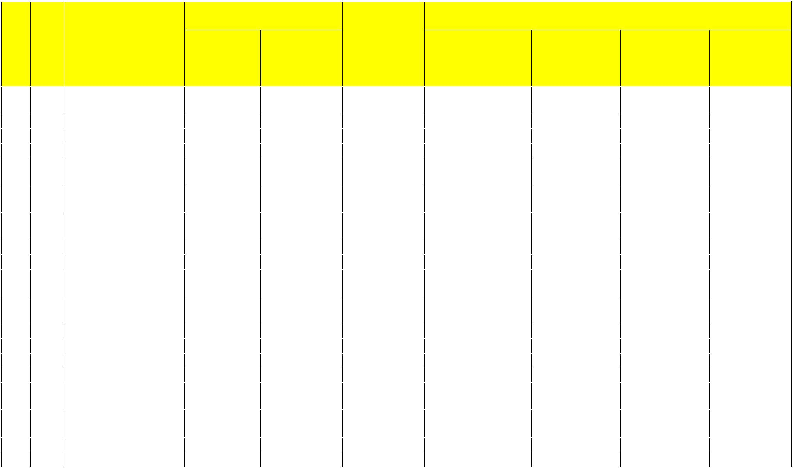
Allocations

151 | 780 |  | Makindye-Ssabagabo | 30,064,486 |  | - |  | 30,064,486 |  |  |  |  |  | -
 |  |  | MC
152 | 781 |  | Kira MC | 12,025,794 |  | - |  | 12,025,794 |  |  |  |  |  | -
153 | 782 |  | Kisoro MC | 92,049 |  | 500,000,000 |  | 500,092,049 | Kisoro MC |  | Central Division |  | Zindiro HC II | 500,000,000
154 | 783 |  | Mityana MC | 18,038,691 |  | - |  | 18,038,691 |  |  |  |  |  | -
155 | 784 |  | Kitgum MC | 92,049 |  | 500,000,000 |  | 500,092,049 | Kitgum MC |  | Pandwong |  | Pandwong HC II | 500,000,000
 |  |  |  |  |  |  |  |  |  |  | Division
156 | 785 |  | Koboko MC | 6,104,946 |  | 500,000,000 |  | 506,104,946 | Koboko MC |  | Southern |  | Koboko Police | 500,000,000
 |  |  |  |  |  |  |  |  |  |  | Division |  | HC II
157 | 786 |  | Mubende MC | 92,049 |  | 500,000,000 |  | 500,092,049 | Mubende MC |  | Mubende West |  | Lwemikomago | 500,000,000
 |  |  |  |  |  |  |  |  |  |  | Division |  | HC II
158 | 787 |  | Kumi MC | 6,012,897 |  | - |  | 6,012,897 |  |  |  |  |  | -
159 | 788 |  | Lugazi MC | 12,025,794 |  | - |  | 12,025,794 |  |  |  |  |  | -
160 | 789 |  | Kamuli MC | 92,049 |  | 500,000,000 |  | 500,092,049 | Kamuli MC |  | Kamuli Southern |  | Busota HC II | 500,000,000
 |  |  |  |  |  |  |  |  |  |  | Division
161 | 790 |  | Kapchorwa MC | 6,104,946 |  | 500,000,000 |  | 506,104,946 | Kapchorwa MC |  | Kapchorwa |  | kaplelko | 500,000,000
 |  |  |  |  |  |  |  |  |  |  | western Division |  | HC II
162 | 791 |  | Ibanda MC | 18,038,691 |  | - |  | 18,038,691 |  |  |  |  |  | -
163 | 792 |  | Njeru MC | 18,038,691 |  | - |  | 18,038,691 |  |  |  |  |  | -
164 | 793 |  | Apac MC | - |  | - |  | - |  |  |  |  |  | -
165 | 794 |  | Nebbi MC | - |  | - |  | - |  |  |  |  |  | -
166 | 795 |  | Bugiri MC | 92,049 |  | 500,000,000 |  | 500,092,049 | Bugiri MC |  | Eastern Division |  | Bugiri Town | 500,000,000
 |  |  |  |  |  |  |  |  |  |  |  |  | Council HC II
167 | 796 |  | Sheema MC | 6,104,946 |  | 500,000,000 |  | 506,104,946 | Sheema MC |  | Kabwohe |  | Kitojo | 500,000,000
 |  |  |  |  |  |  |  |  |  |  | Division |  | Community HC II
168 | 797 |  | Kotido MC | 6,012,897 |  | - |  | 6,012,897 |  |  |  |  |  | -
 |  |  |  | 7,360,894,450 |  | 62,000,000,000 |  | 69,360,894,450 | - | - |  | - |  | 62,000,000,000
 |  |  |  |  |  |  |  | 30

6.3 Annex III: Transitional Development Health Ad Hoc Beneficiary Health Facilities for FY2018/19.


 |  |  |  |  |  | Transitional
S/N |  | District | Vote | Beneficiary Health Facility |  | Development
 |  |  |  |  |  | - Health Ad Hoc
1 |  | Apac District | 502 | Apac General Hospital | 300,000,000
2 |  | Kamwenge District | 518 | Rukunyu HC IV | 250,000,000
3 |  | Kiboga District | 525 | Kiboga General Hospital | 400,000,000
4 |  | Mpigi District | 540 | Mpigi HCIV | 300,000,000
5 |  | Tororo District | 554 | Tororo General Hospital | 250,000,000
6 |  | Abim District | 573 | Abim General Hospital | 300,000,000
7 |  | Maracha District | 577 | Maracha HC IV | 200,000,000
8 |  | Kyotera District | 621 | Kalisizo Hospital | 200,000,000
 |  | Total |  |  |  | 2,200,000,000

31
6.4 Annex IV: LG Health Performance Measures for Assessment in FY 2018/19

The following Health performance measures and the corresponding score points will form the basis for LG performance assessment. These performance measures were developed to address the key issues in the management of service delivery. The LG performance based on these measures will therefore impact the size of the Health Development Grant that will be allocated to the LG.

- Human resource planning and management - maximum 22 points

      - LG has substantively recruited primary health care workers with a wage bill provision from PHC wage — maximum 6 points

      - The LG Health department has submitted. A comprehensive recruitment plan to the HRM departments -- maximum 4 points.

      - The LG. Health department has properly conducted performance appraisal for the. Health facility in-charges – 8 points.

      - The LG Health department has equitably deployed health workers across health facilities and in accordance with the staff lists submitted together with the budget in the current FY — maximum 4 points.

  - Monitoring & supervision – maximum 38 Points

      - The DHO has effectively communicated and explained guidelines, policies, circulars issued by the national level in the previous FY to health facilities - maximum 6 points.

      - The LG Health. Department has effectively provided support supervision to district health services — maximum -6 points.

      - The Health Sub-district(s) have effectively provided support Supervision to lower level health units — maximum 6 points.

      - The LG Health department (including HSDs) has discussed the results/reports of the support/supervision and monitoring visits, used them to make recommendations for corrective actions and followed up — maximum 10 points.

      - The LG Health department has submitted accurate/consistent reports/ data for health facility lists as per formats provided by MoH — maximum 10 points.

  - Governance, oversight, transparency-and accountability - maximum 12 points

    - The LG committee responsible for health met, discussed service delivery issues and presented issues that require approval to council — maximum 4 paints.

32
- The Health Unit Management Committees and Hospital Board(s) are operational/ functional -- maximum 5 points.

- The LG has publicized all health facilities receiving PHC non-wage recurrent grants - maximum 3 points

  - Procurement and contract management - maximum 14 points

    - The LG Health department has submitted procurement requests to PDU that cover all items in the approved Sector annual work plan and budget — maximum 4 points

    - The LG Health department has supported all health facilities to submit health supplies procurement plan to NMS - maximum, 8 points

    - The LG Heath department has certified and initiated payment for works and supplies on time - maximum 2 points:

- Financial management and reporting - maximum 8 points

    - The LG Health department has submitted annual (including all quarterly Reports) in time to the Planning Unlit- maximum 4 points

    - LG Health department has acted on Internal Audit recommendations-(if any) - maximum 4 points

  - Social and environment safeguards — maximum 6 points

    - Compliance with gender composition of HUMC and promotion of gender sensitive sanitation in health facilities — maximum 4 points.

    - The LG Health department has issued guidelines on medical waste management — maximum 2 points

33
6.5 Annex V: Outputs and Indicators

Vote Function: 0881 Primary Health Centre and Sanitation Services

Output: 088101 Public Health Promotion

Output: 088104 Medical Supplies for Health Facilities

Indicator: Number of health facilities reporting no stock out of the 6 tracer drugs.

Indicator: Value of essential medicines and health supplies delivered to health facilities by NMS

Indicator: Value of health supplies and medicines delivered to health facilities by NMS

Output: 088106 Promotion of Sanitation and Hygiene

Output: 088153 NGO Basic Healthcare Services (LLS)

Indicator: Number of children immunized with Pentavalent vaccine in the NGO Basic health facilities

Indicator: No. and proportion of deliveries conducted in the NGO Basic health facilities

Indicator: Number of outpatients that visited the NGO Basic health facilities

Indicator: Number of inpatients that visited the NGO Basic health facilities

Output: 088154 Basic Healthcare Services (HCIV-HCII-LLS)

Indicator: Number of trained health workers in health Centres

Indicator: No.of trained health related training sessions held.

Indicator: Number of outpatients that visited the Govt. health facilities.

Indicator: Number of inpatients that visited the Govt. health facilities.

Indicator: No. and proportion of deliveries conducted in the Govt. health facilities

Indicator: %age of approved posts filled with qualified health workers

Indicator: %of Villages with functional (existing, trained, and reporting quarterly) VHTs.

Indicator: No. of children immunized with Pentavalent vaccine

Output: 088155 Standard Pit Latrine Constructions (LLS.)

Indicator: No. of new standard pit latrines constructed in a village

Indicator: No. of villages which have been declared Open Defecation Free(ODF)

Output: 088156 Hand Washing facility installations (LLS.)

Indicator: No of standard hand washing facilities (tippy tap) installed next to the pit latrines

Output: 088159 Multi sectoral Transfers to Lower Local Governments

Output: 088175 Other Service Delivery Capital Investments

Output: 088180 Health Centre construction and rehabilitation

Indicator: No of healthcentres constructed

Indicator: No of health Centres rehabilitated

Output: 088181 Staff houses construction and rehabilitation

Indicator: No of staff houses constructed

Indicator: No of staff houses rehabilitated

Output: 088182 Maternity ward construction and rehabilitation

Indicator: No of maternity wards constructed

Indicator: No of maternity wards rehabilitated

Output: 088183 OPD and other ward construction and rehabilitation

Indicator: No of OPD and other wards constructed

Indicator: No of OPD and other wards rehabilitated

Output: 088184 Theatre construction and rehabilitation

Indicator: No of theatres constructed

Indicator: No of theatres rehabilitated

Output: 088185 Specialist health equipment and machinery

Indicator: Value of medical equipment procured

Vote Function: 0882 District Hospital Services

Output: 088251 District Hospital Services (LLS.)

Output: 088275 Other Service Delivery Capital Investment

Output: 088280 Hospital construction and rehabilitation

Output: 088281 Staff houses construction and rehabilitation

Output: 088282 Maternity ward construction and rehabilitation

Output: 088283 OPD and other ward construction and rehabilitation

Output: 088284 Theatre construction and rehabilitation
Output: 088285 Specialist health equipment and machinery

Vote Function: 0883 Health Management and Supervision

Output: 088301 Healthcare Management Services

Output: 088302 Healthcare Services Monitoring and Inspection

Output: 088303 Sector Capacity Developments

Output: 088372 Administrative Capital Investments

34

